**Practical No. 5**

**Aim**: To understand the ETL operation in Data Warehousing

**Prerequisite:**

* Concepts of Relational Schema, Tables, simple SQL query writing and referential integrity in DBMS.

**Outcome:** After successful completion of this experiment students will be able to

* Install SQL server 2019 & creation of tables to understand concepts of Referential integrity.
* Extract OLTP files & load it in to SQL Server.
* Perform the few transformation operation of data warehousing using SSIS Package

**Installation of SQL Server 2019**

Download Developer edition (EXE file)

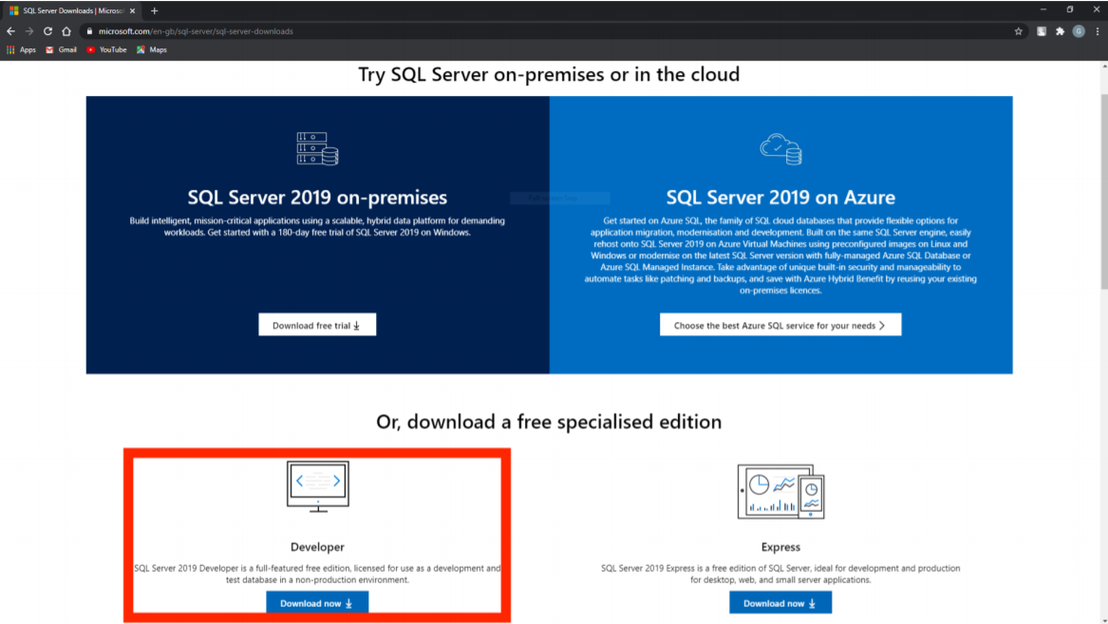

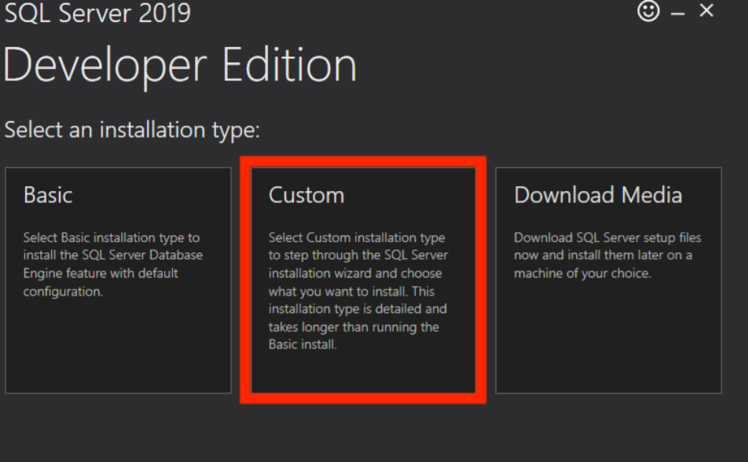

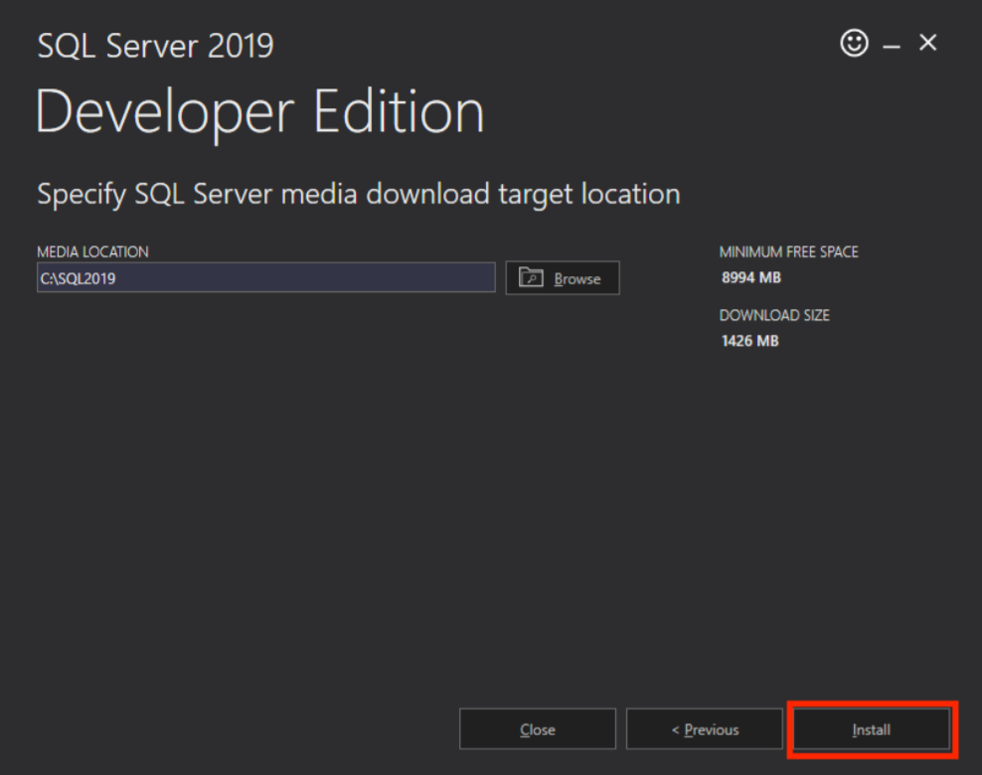

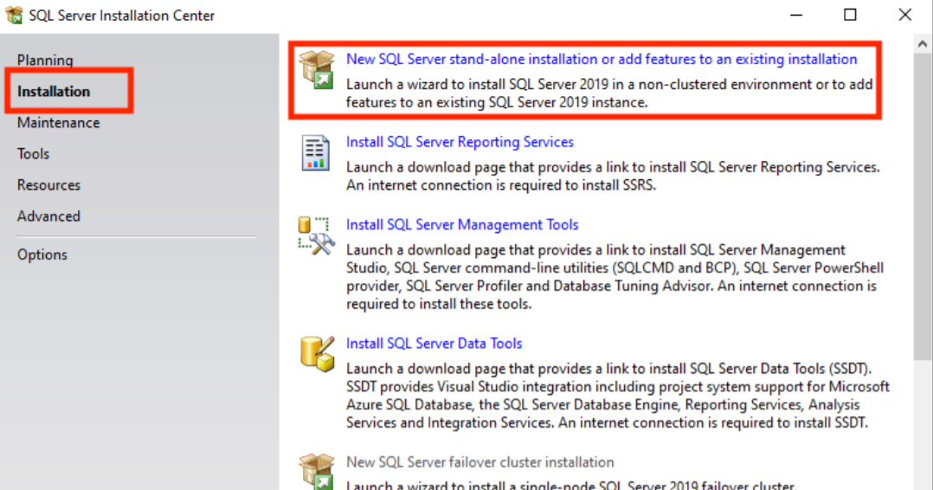

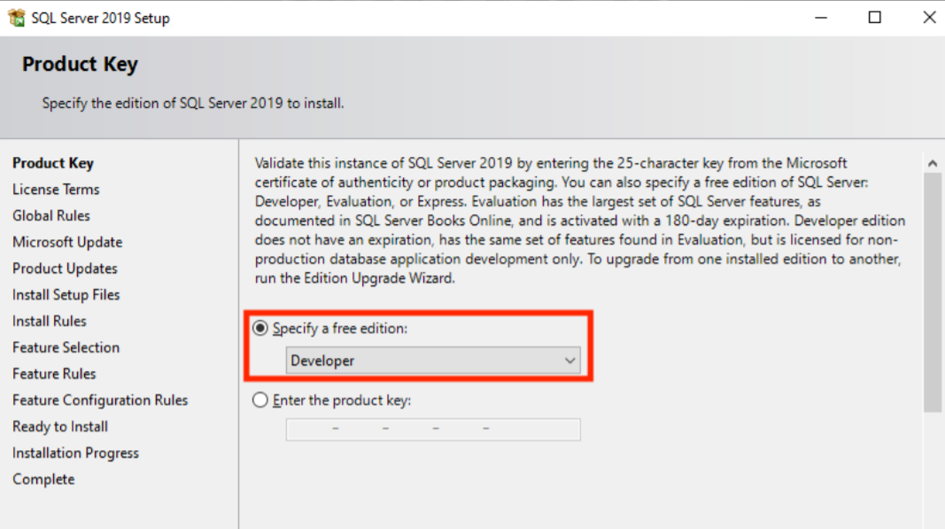

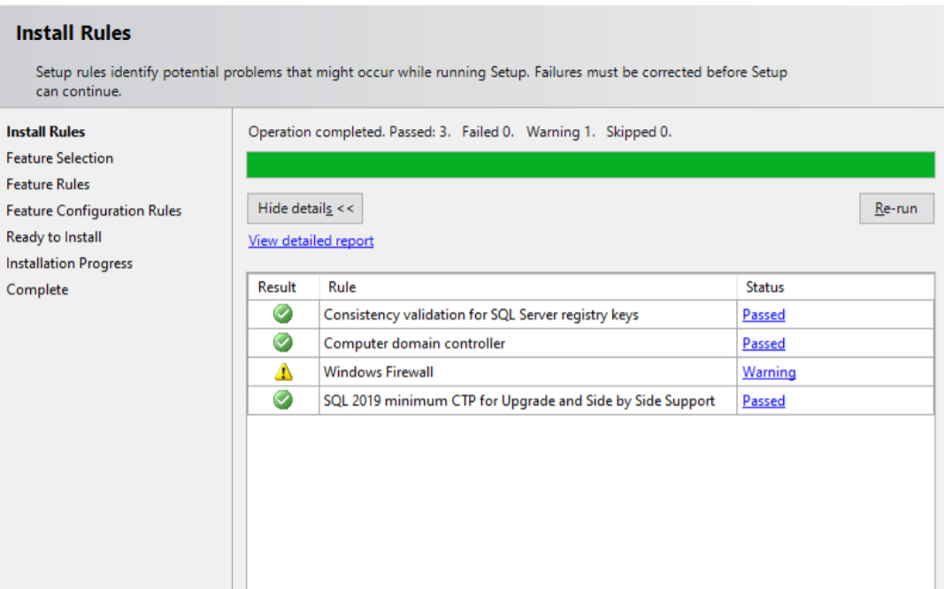

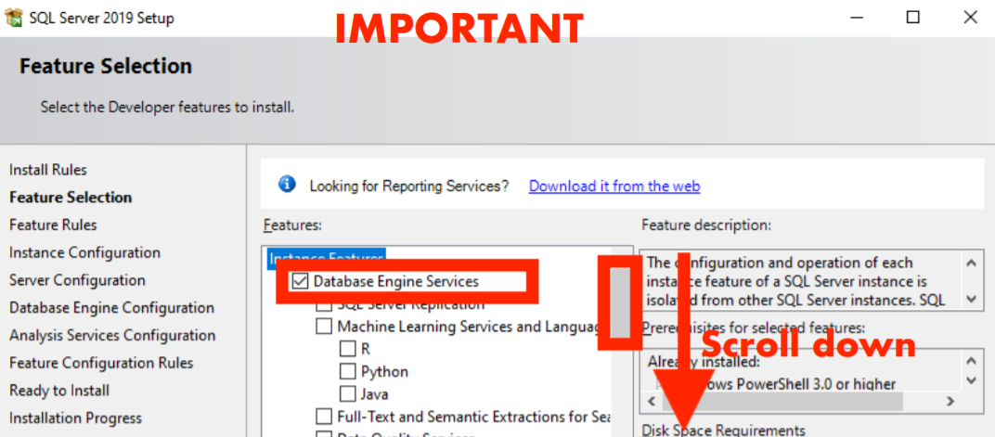

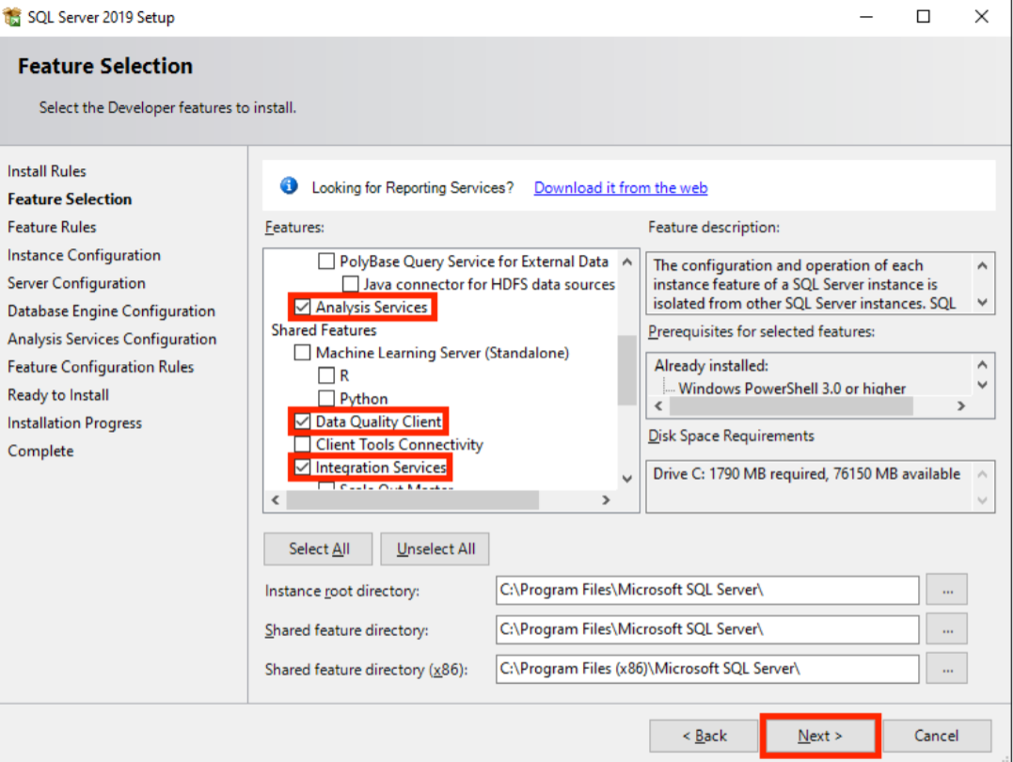

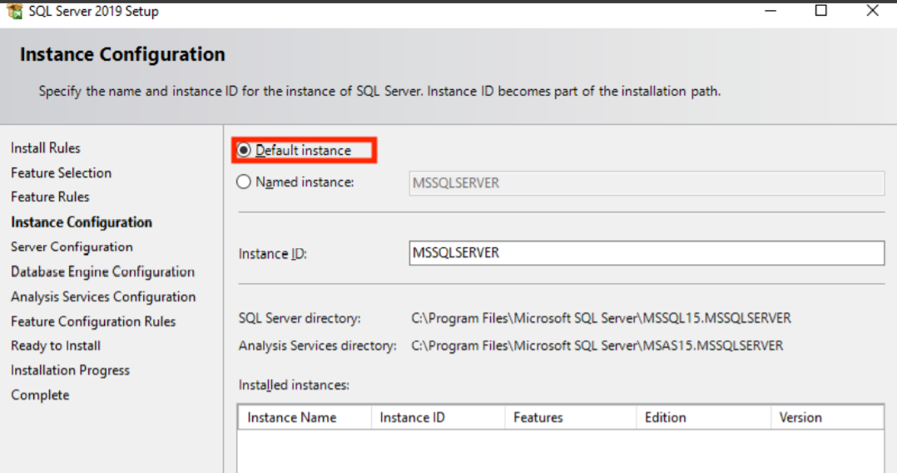

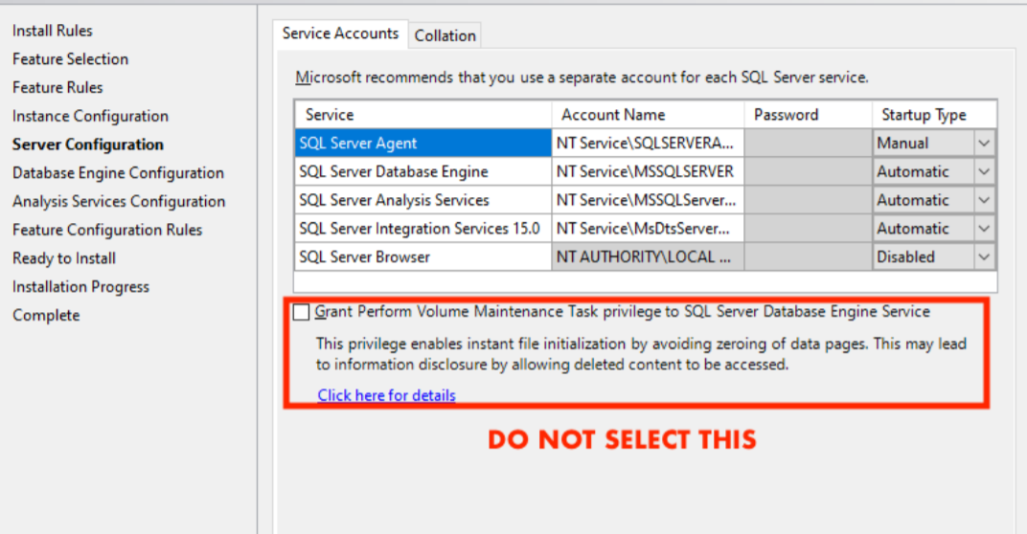

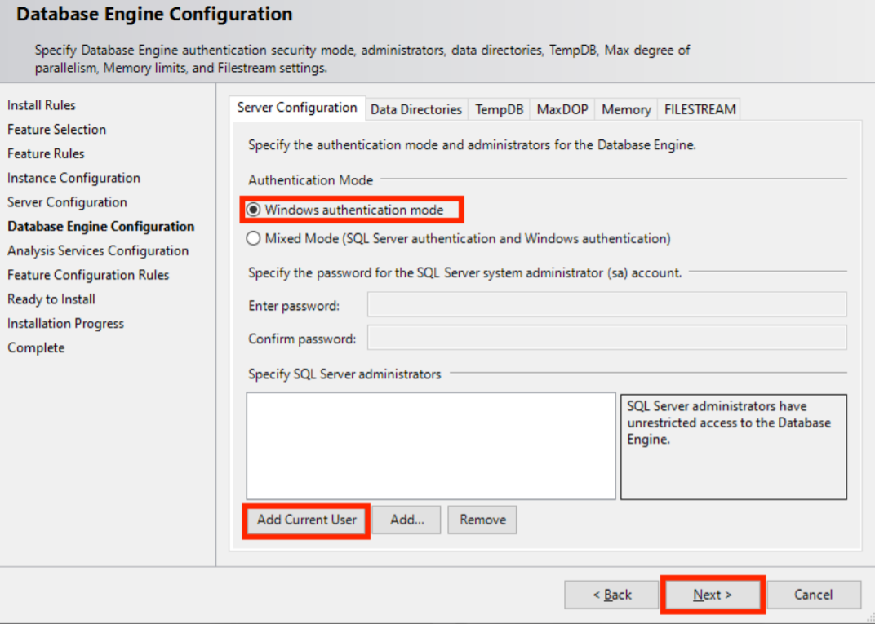

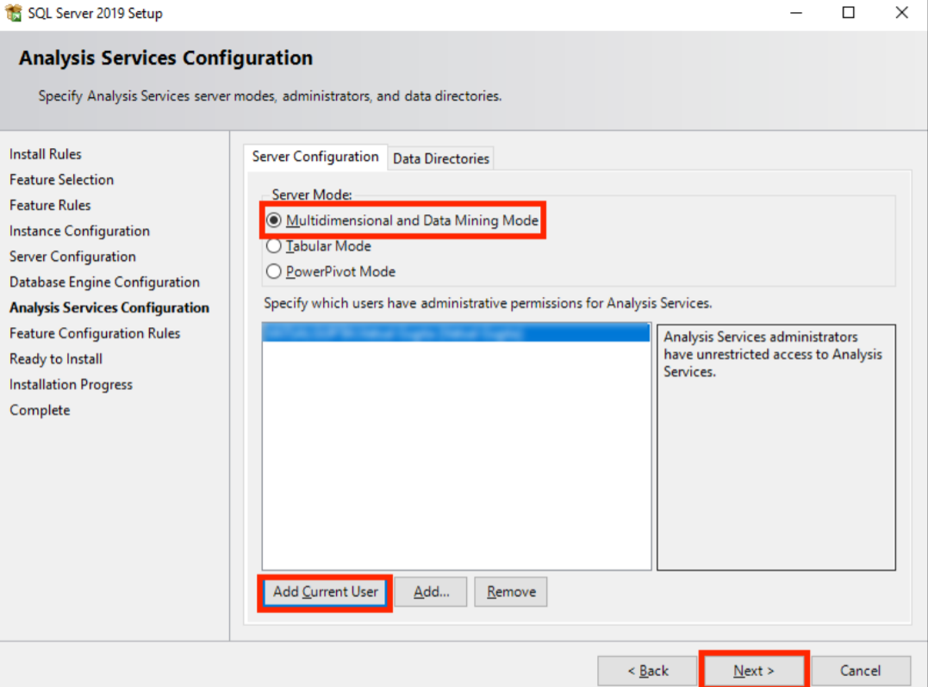

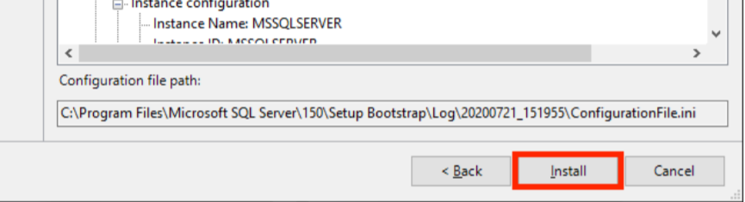

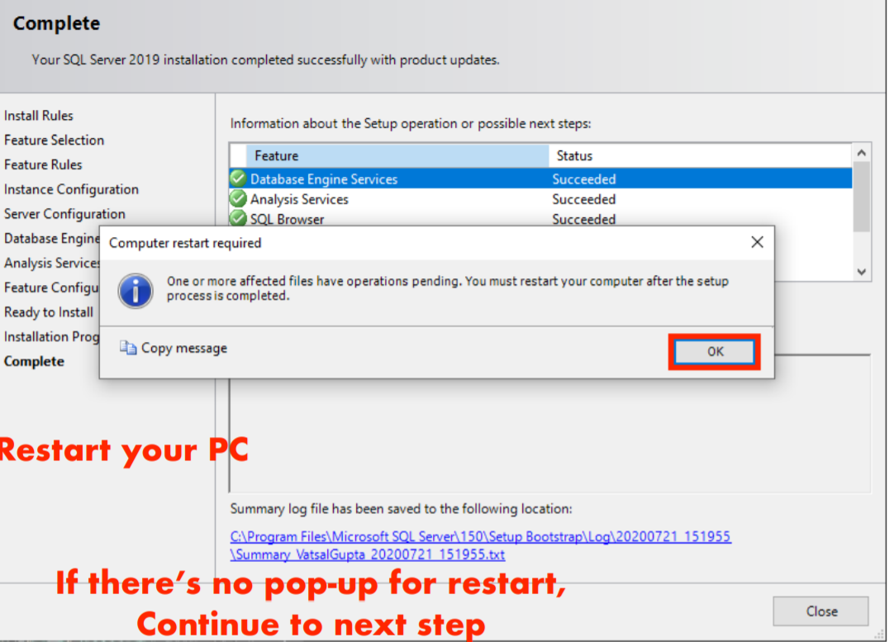

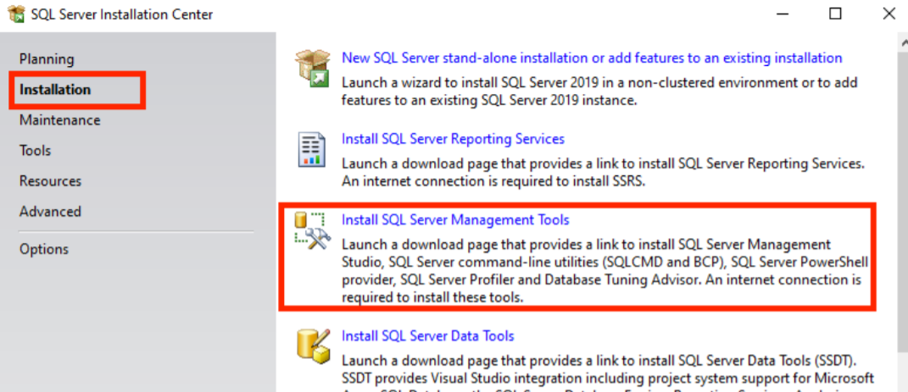

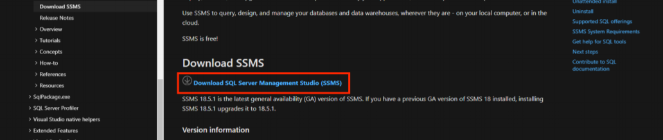

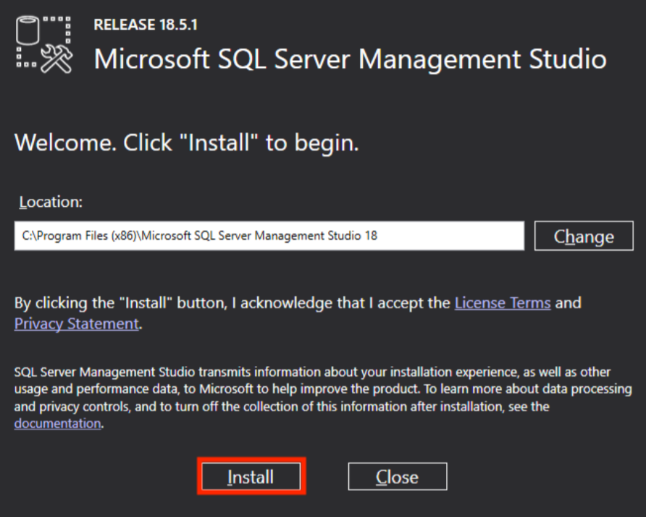

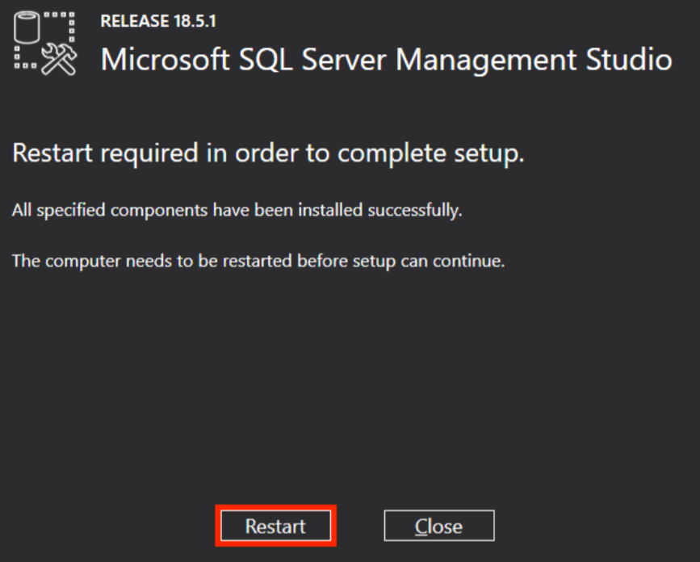

**Creating Database and tables:**

**COMMANDS**

* create database superstore
* use superstore
* create table products(productID int, productname char(200), manufacturer char(20))
* insert into products values (1, 'ParleG', 'Parle'), (2, 'hidenseek', 'Parle'), (3, 'lux', 'hindustan')
* select * from products
* create table customer (custID int, custname varchar(20), Telno int, bdate date)
* insert into customer values (1, 'Ashwini', 123456789, '1982-08-07'), (2, 'XYZ', 987654321, '1979-12-07'), (3, 'PQR', 1122334455, '1978-09-12')
* select * from customer
* create table transactions (transID char (15), custID int, productID int, salesamt float, transdate date)
* insert into transactions values ('ALL', 1, 5, 3500, GETDATE())

*This is to demonstrate that as there are no primary key and foreign key in the above created tables, so could add product id 5 into transaction table which is incorrect. Now we again create the same tables using primary and foreign key.*

* drop table products
* drop table customer
* drop table transactions
* create table products(productID int PRIMARY KEY, productname char(200), manufacturer char(20))
* insert into products values (1, 'ParleG', 'Parle'), (2, 'hidenseek', 'Parle'), (3, 'lux', 'hindustan')
* select * from products
* create table customer (custID int PRIMARY KEY, custname varchar(20), Telno int, bdate date)
* insert into customer values (1, 'Ashwini', 123456789, '1982-08-07'), (2, 'XYZ', 987654321, '1979-12-07'), (3, 'PQR', 1122334455, '1978-09-12')
* select * from customer
* create table transactions (transID char (15) PRIMARY KEY, custID int references customer(custID), productID int references products (productID), salesamt float, transdate date)
* insert into transactions values ('ALL', 1, 3, 3500, GETDATE())
* select * from transactions

**Creating a Star Schema:**

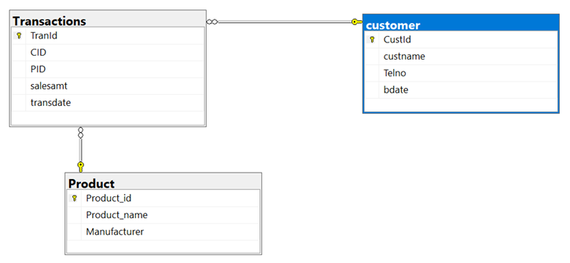

**Installation of Visual Studio 2019 & SSIS Package for ETL operation**

Visual Studio Community 2019 Installation

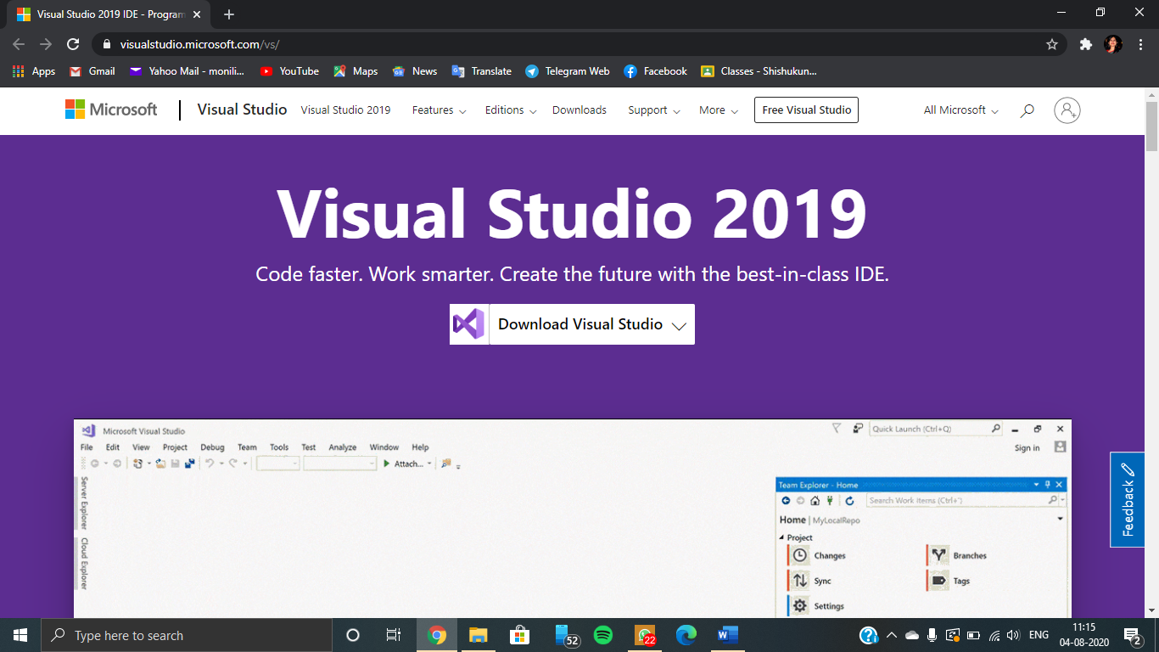

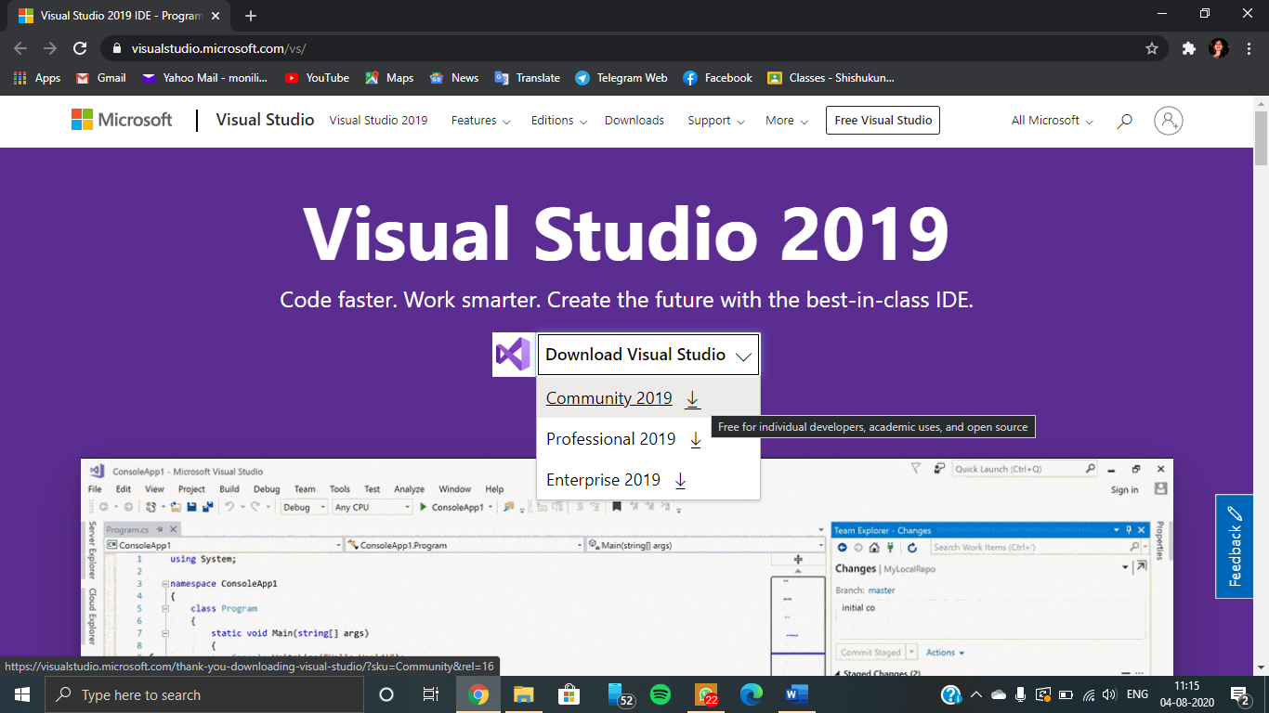

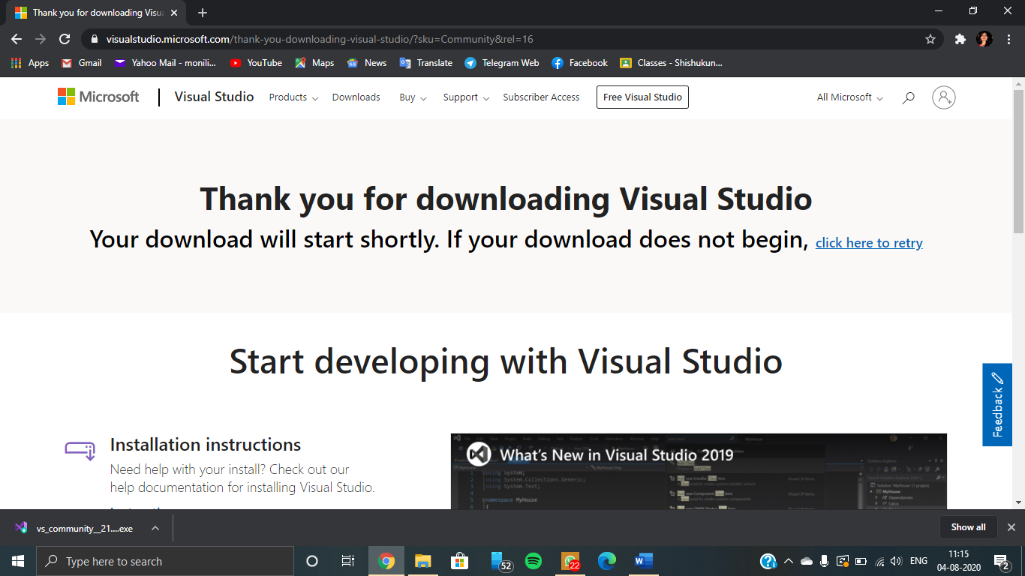

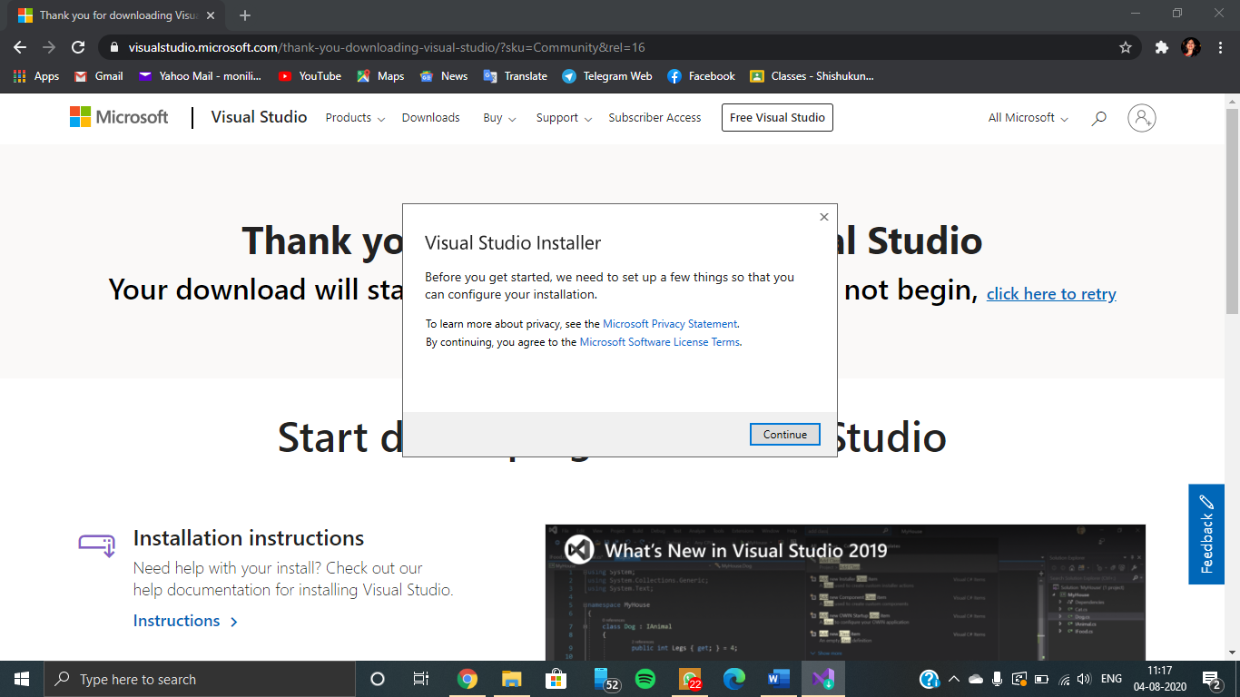

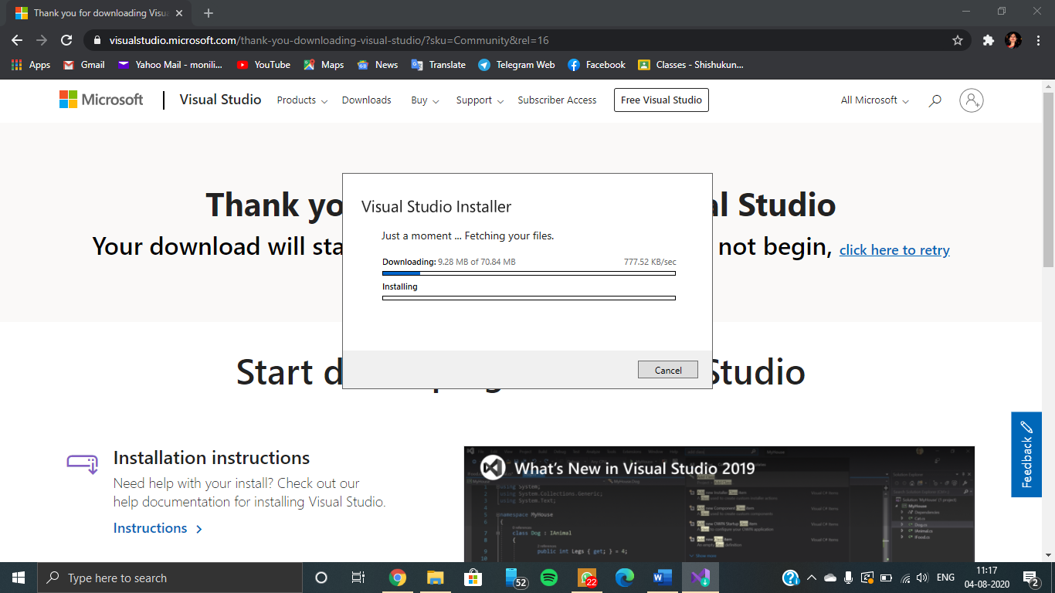

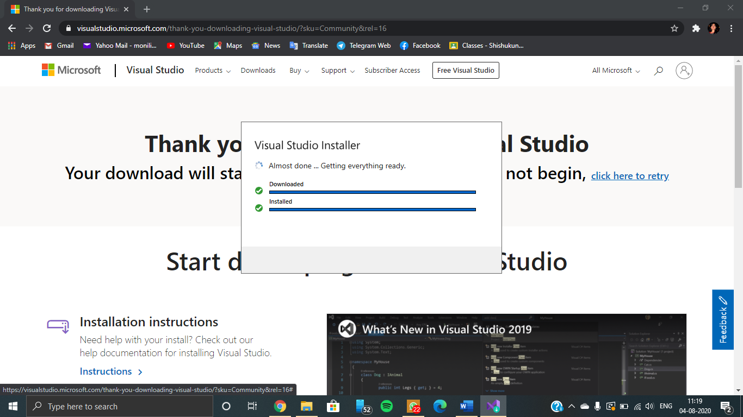

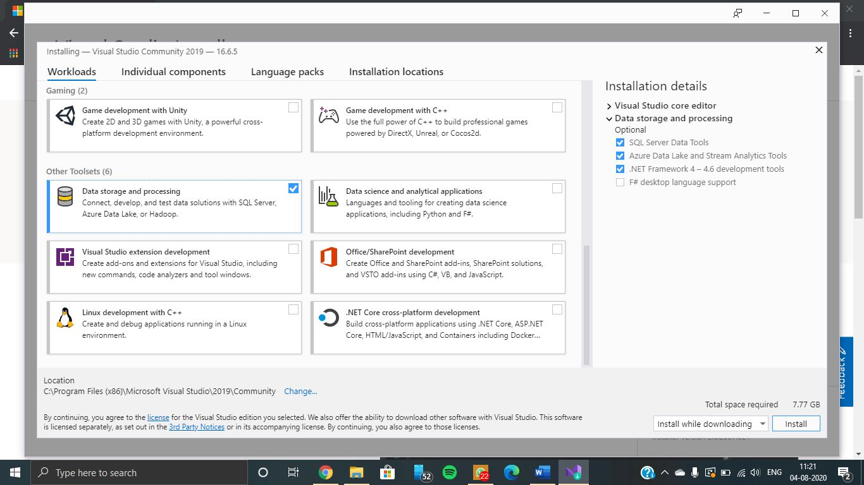

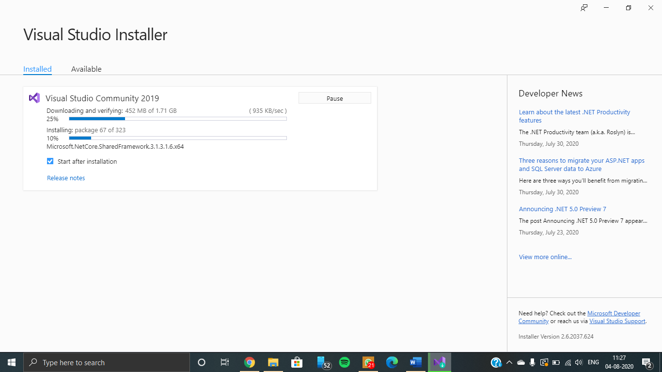

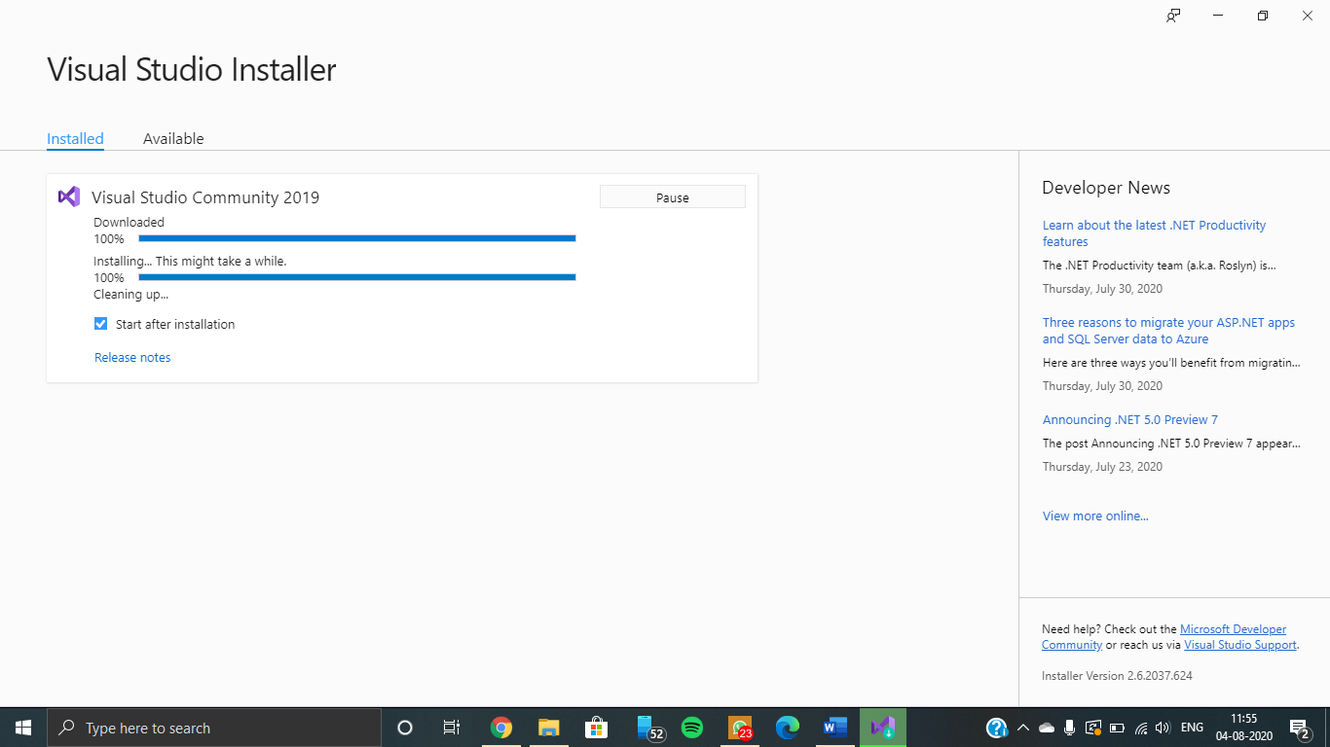

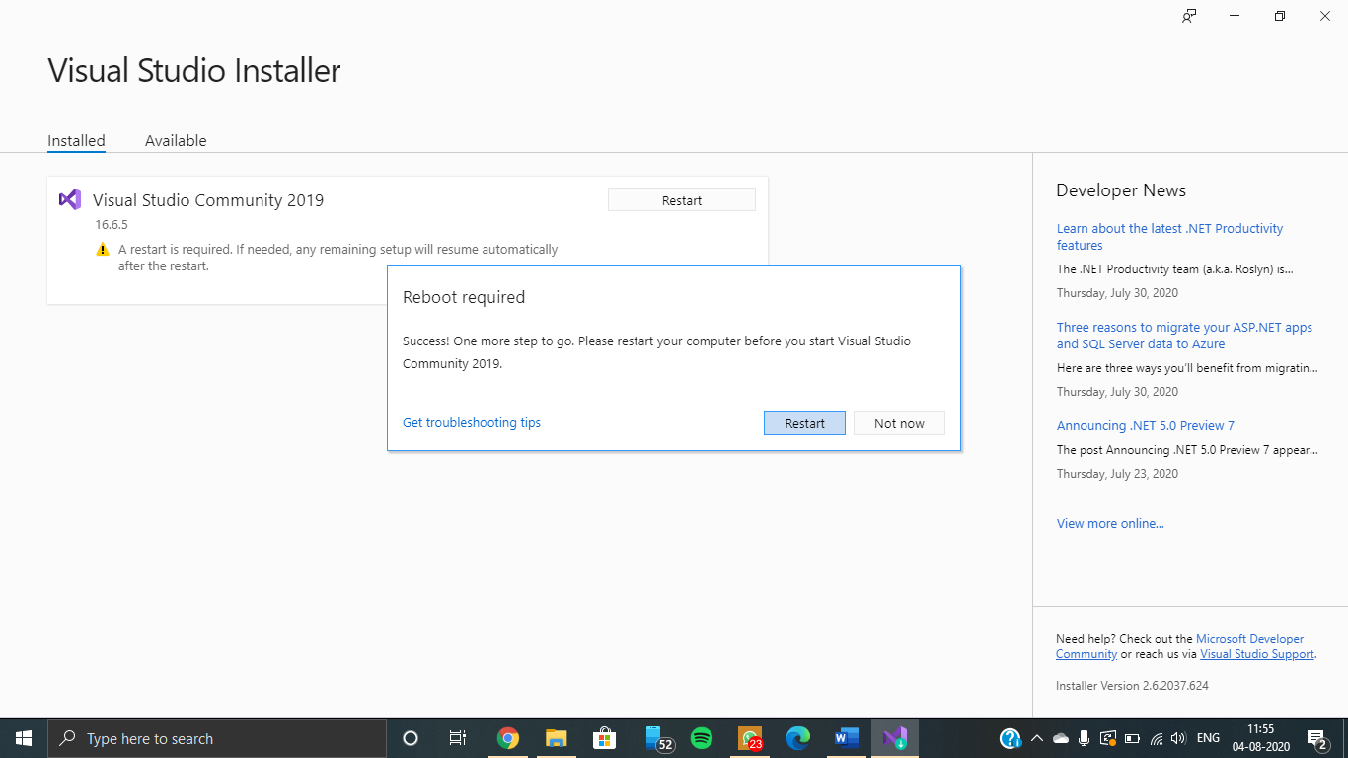

**SSIS Extension Installation**

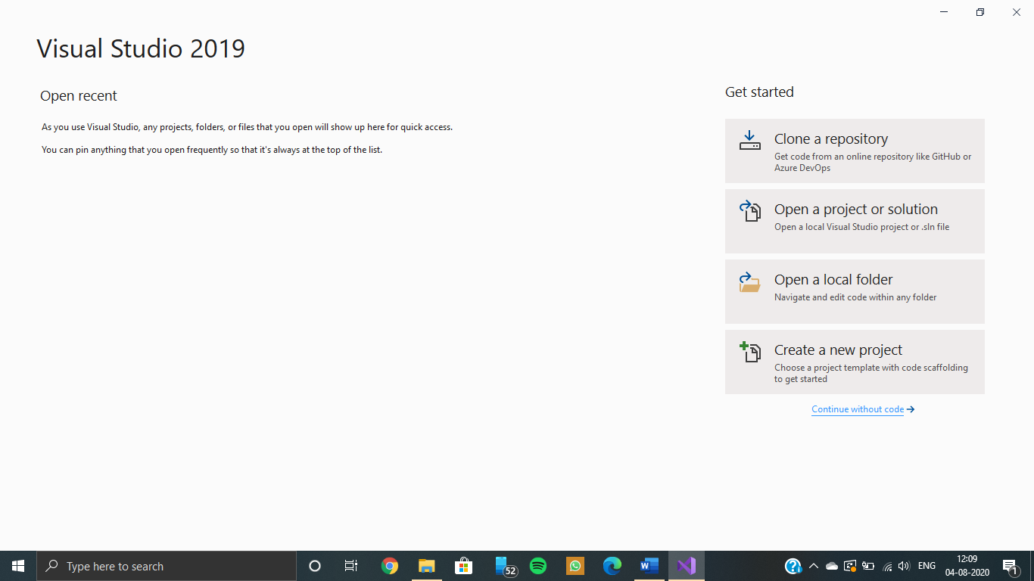

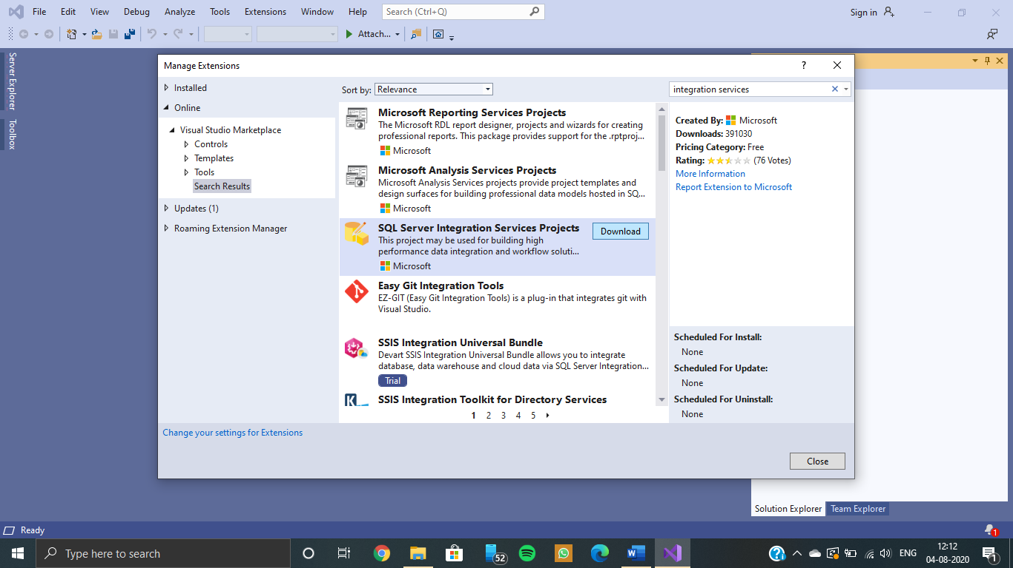

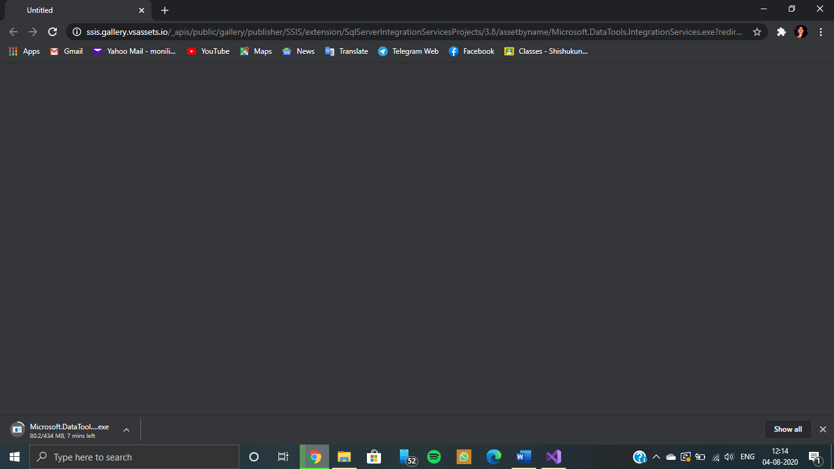

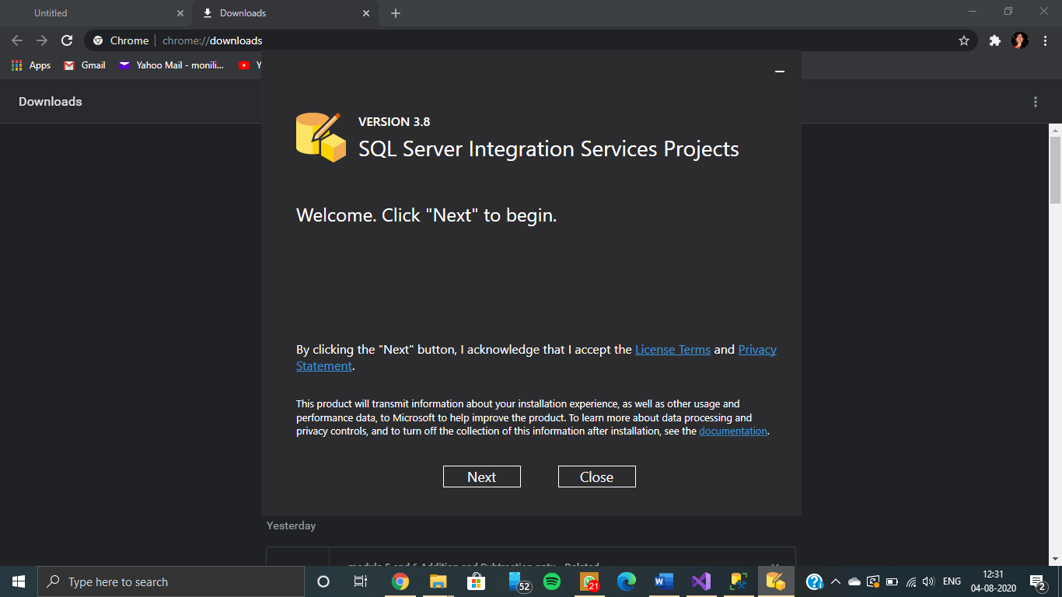

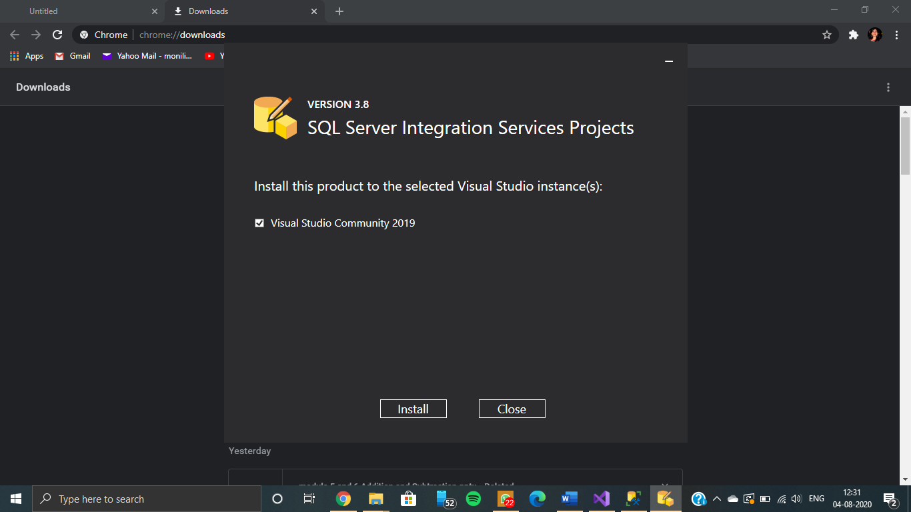

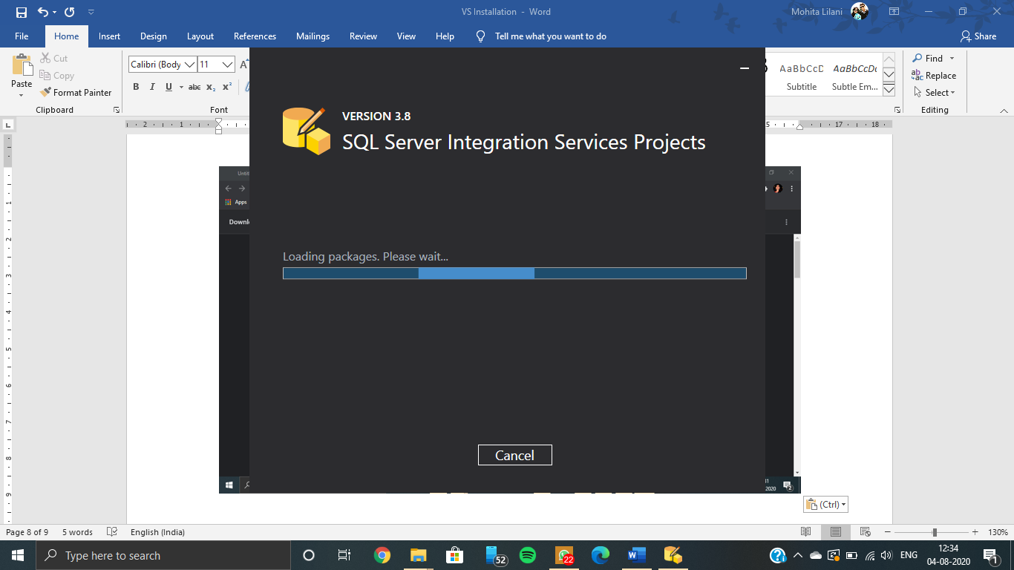

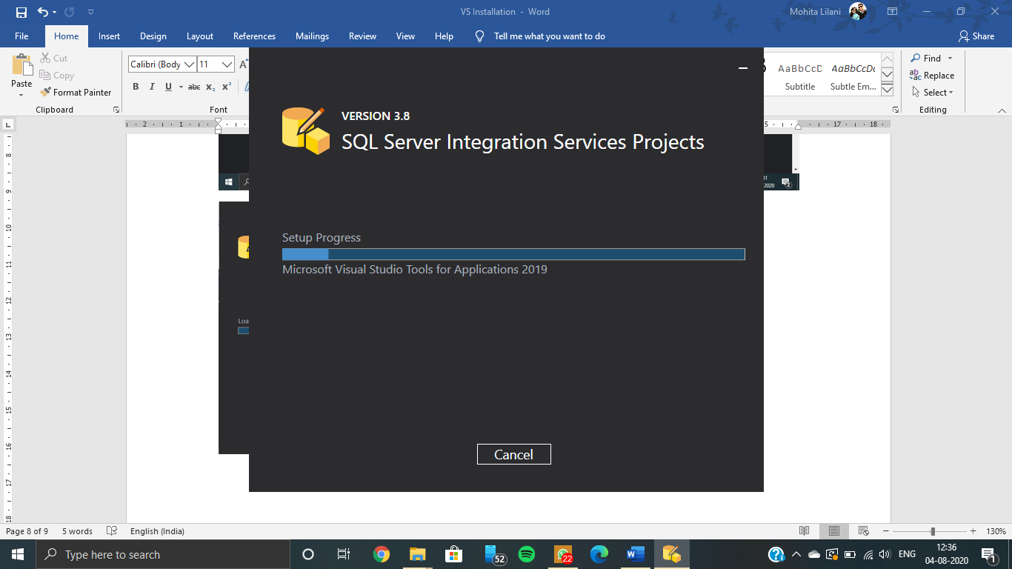

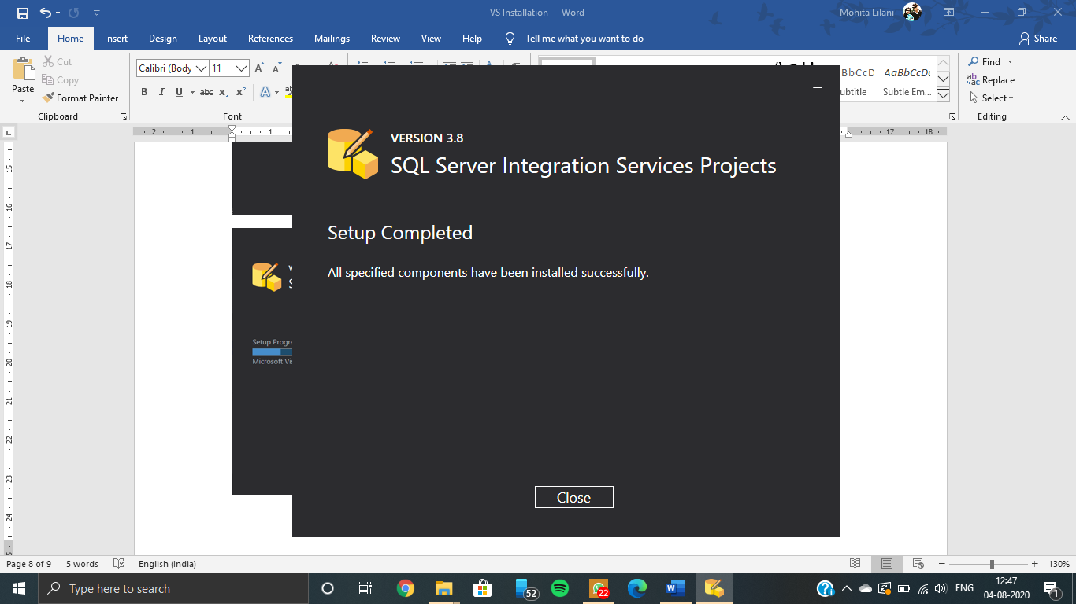

**Installation of Visual Studio 2019 & SSIS Package for ETL operation**

Visual Studio Community 2019 Installation





















**SSIS Extension Installation**

















**Perform the ETL operation of data warehousing using SSIS Package**

Creation of PHONES table on SQL Server 2019

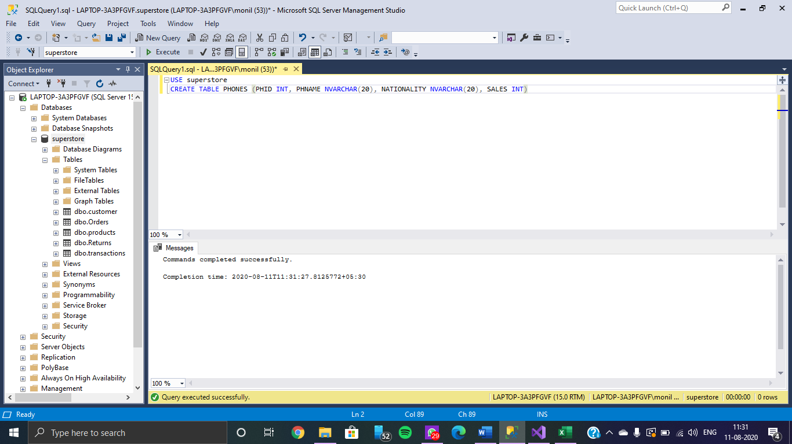

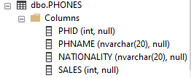

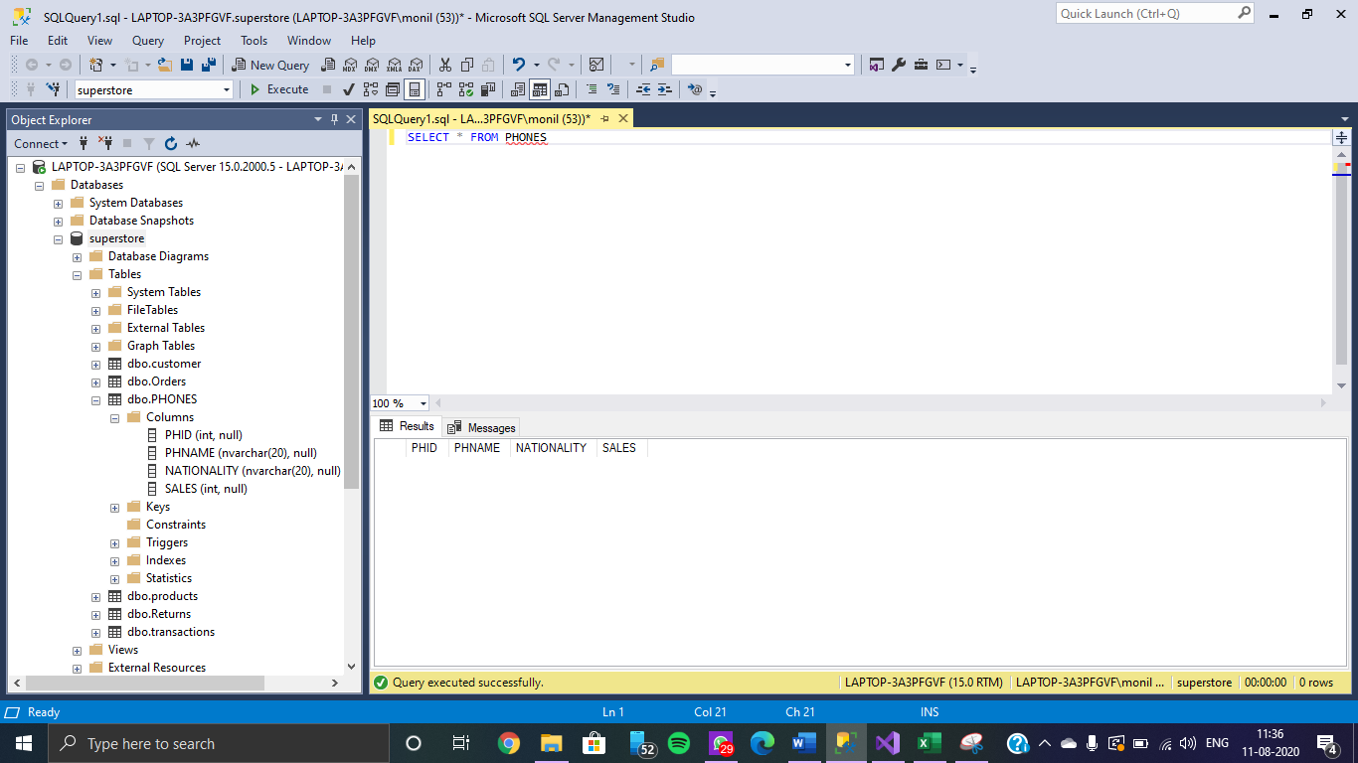

**Creating our Project on Visual Studio 2019**

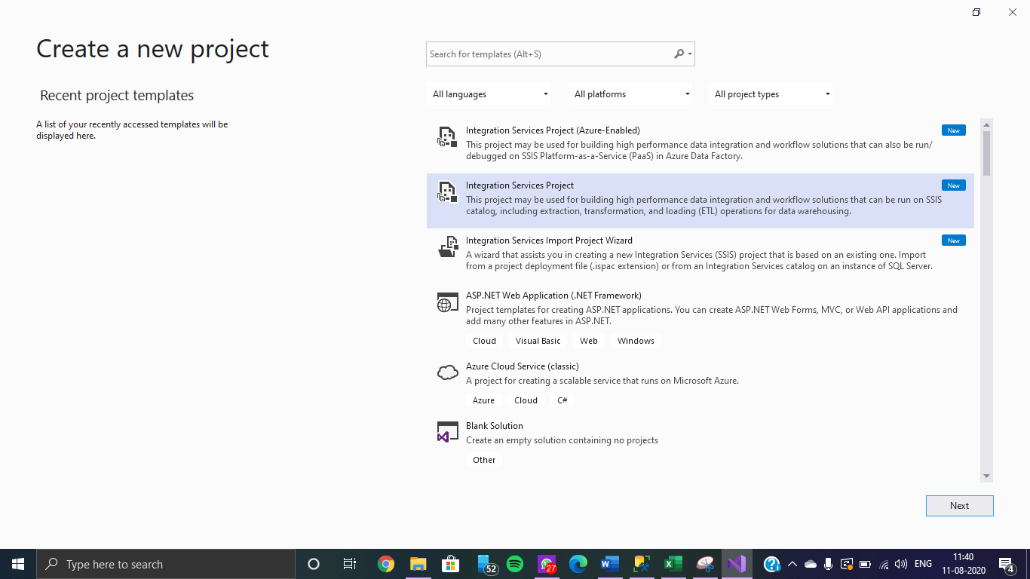

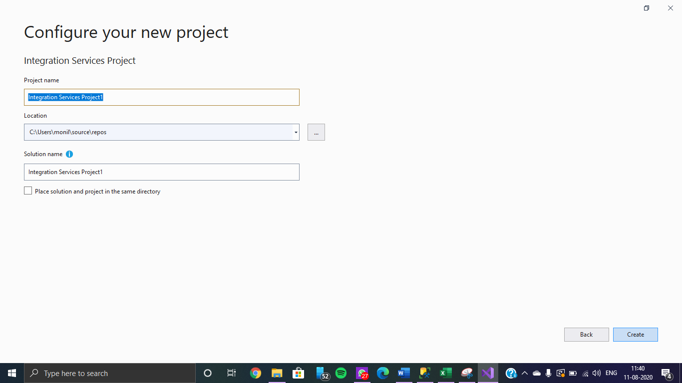

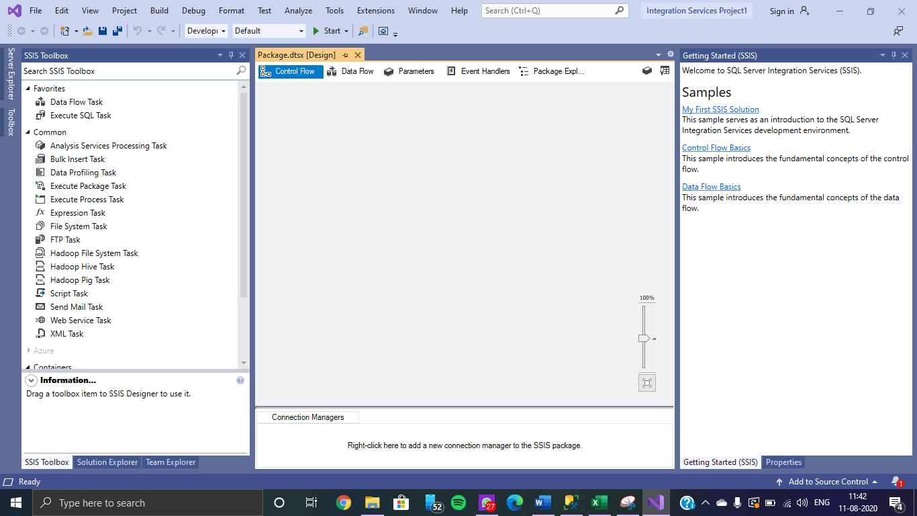

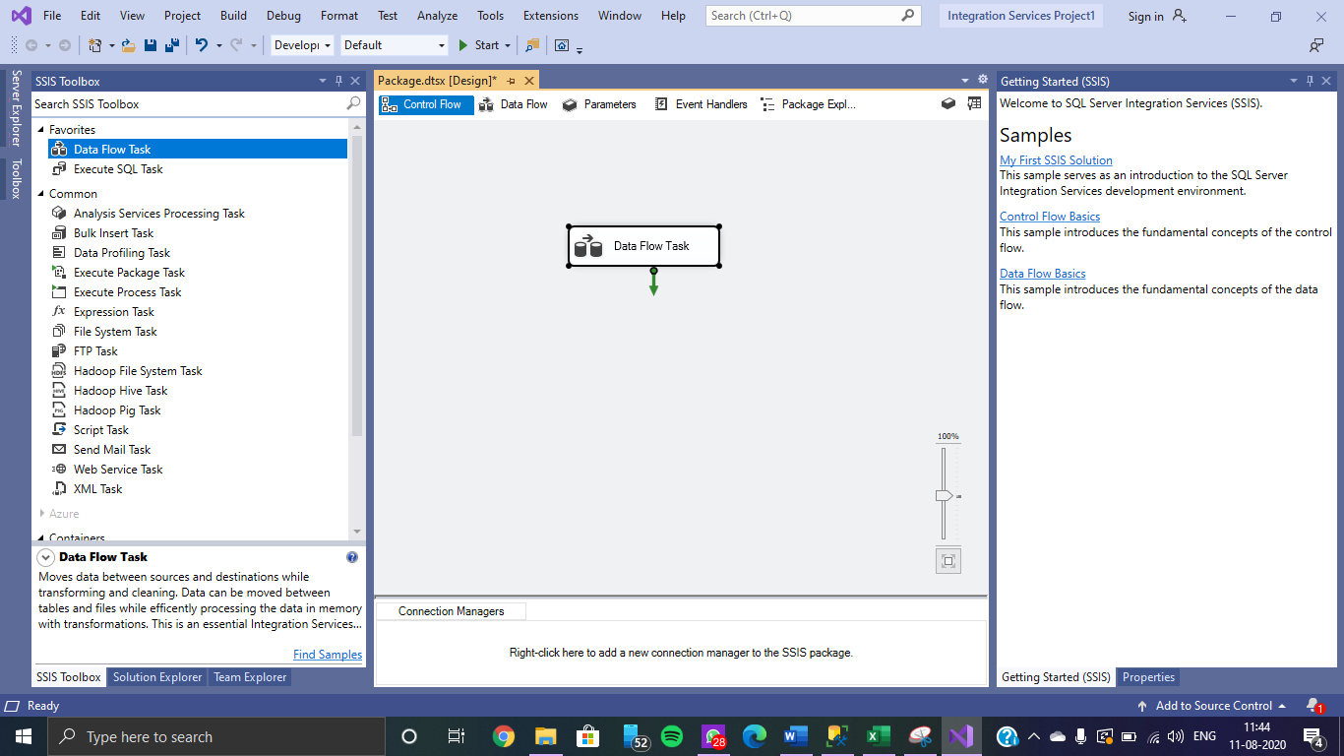

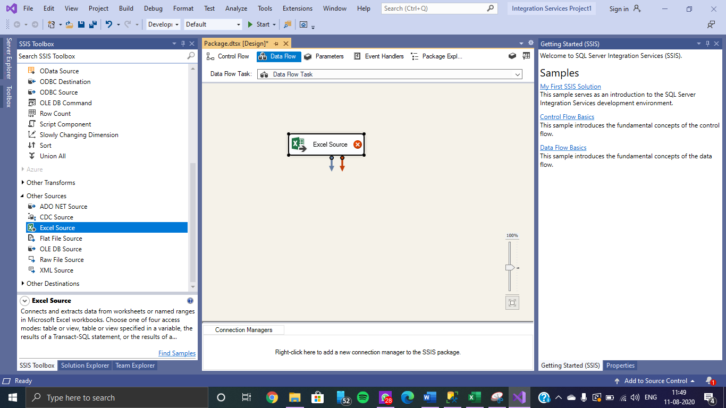

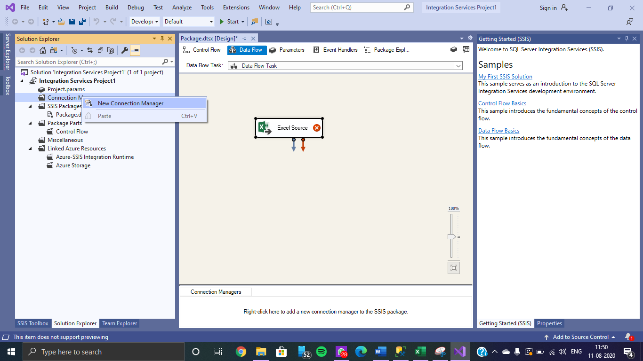

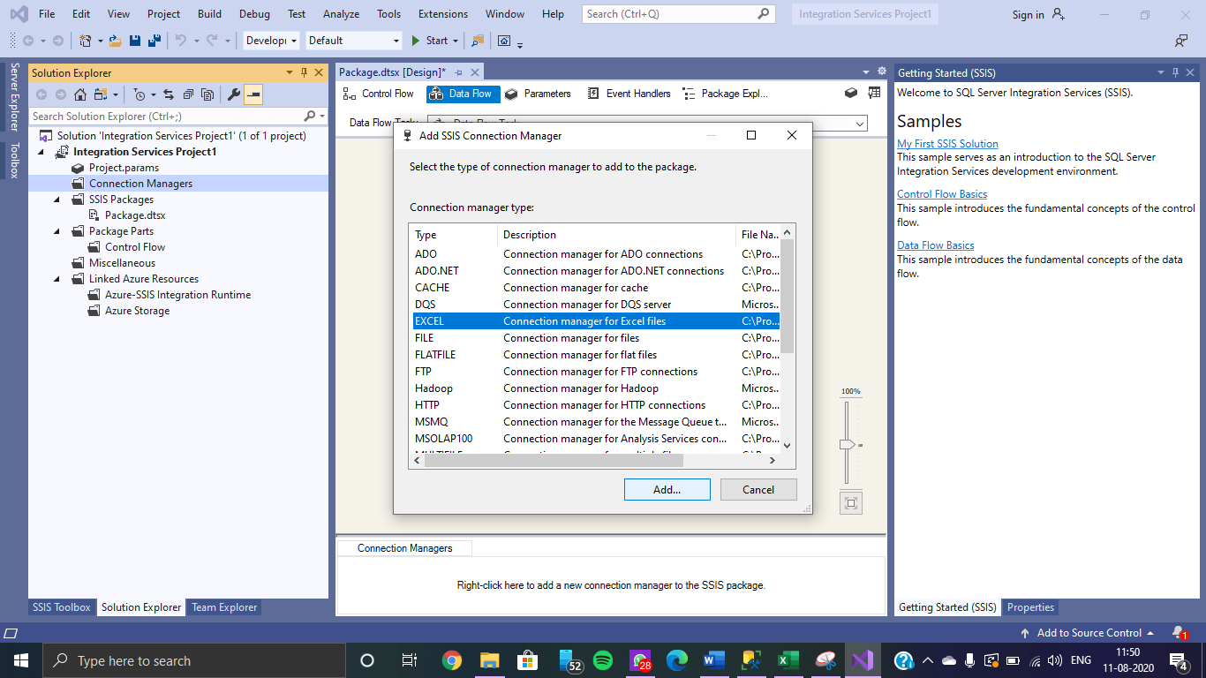

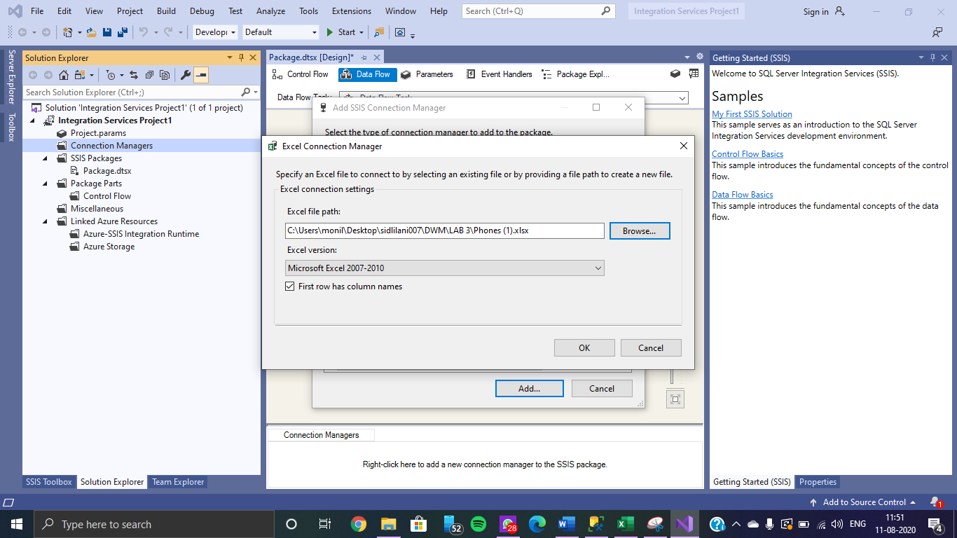

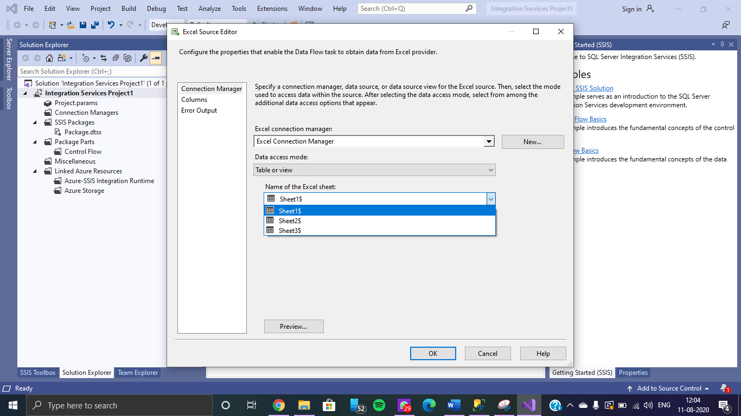

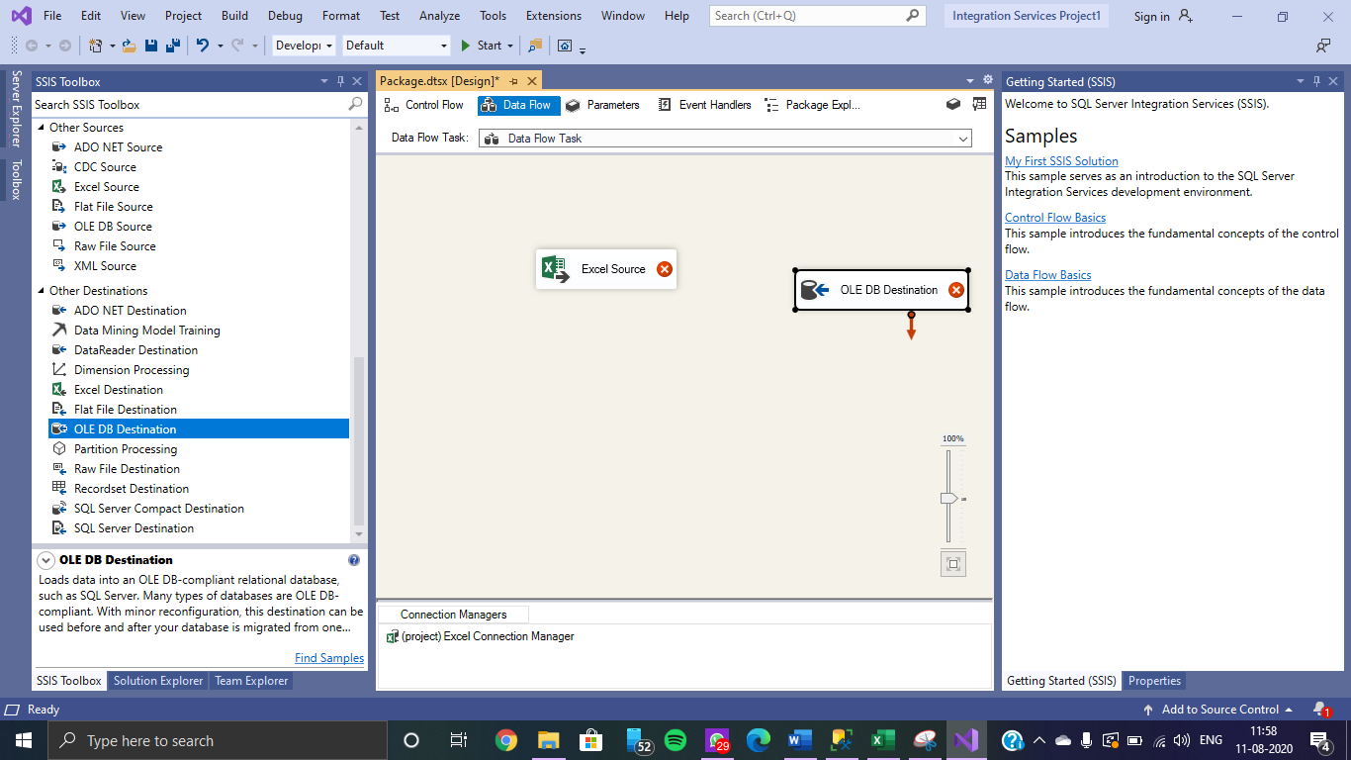

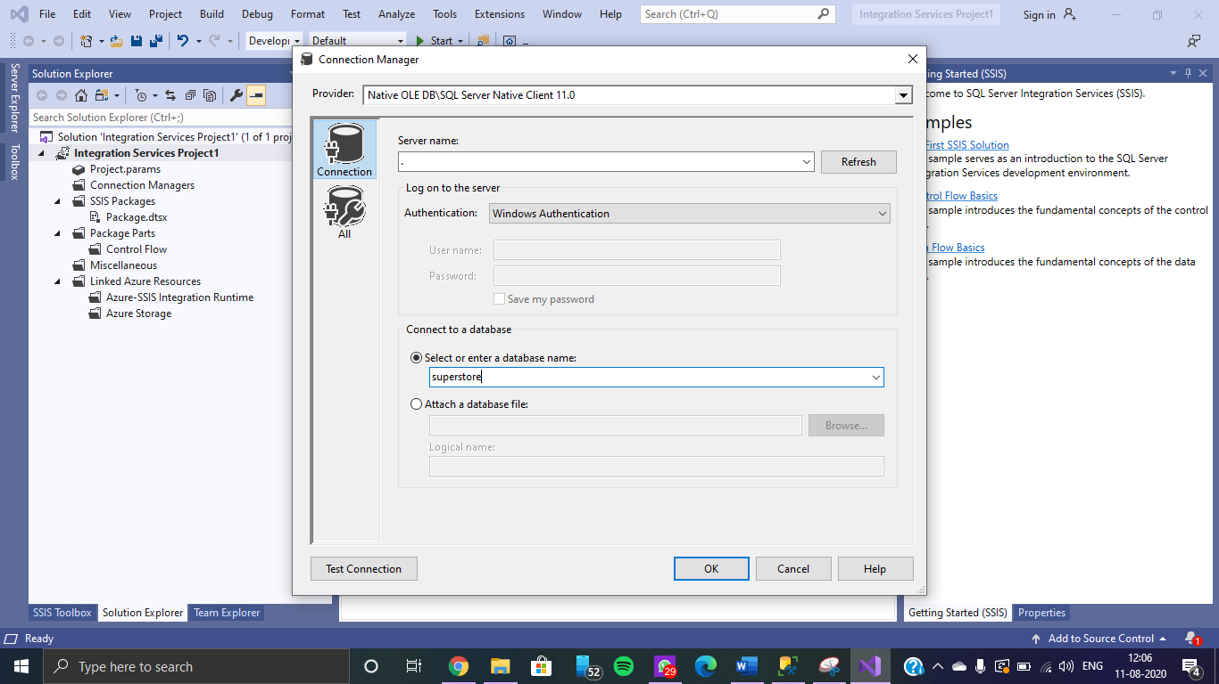

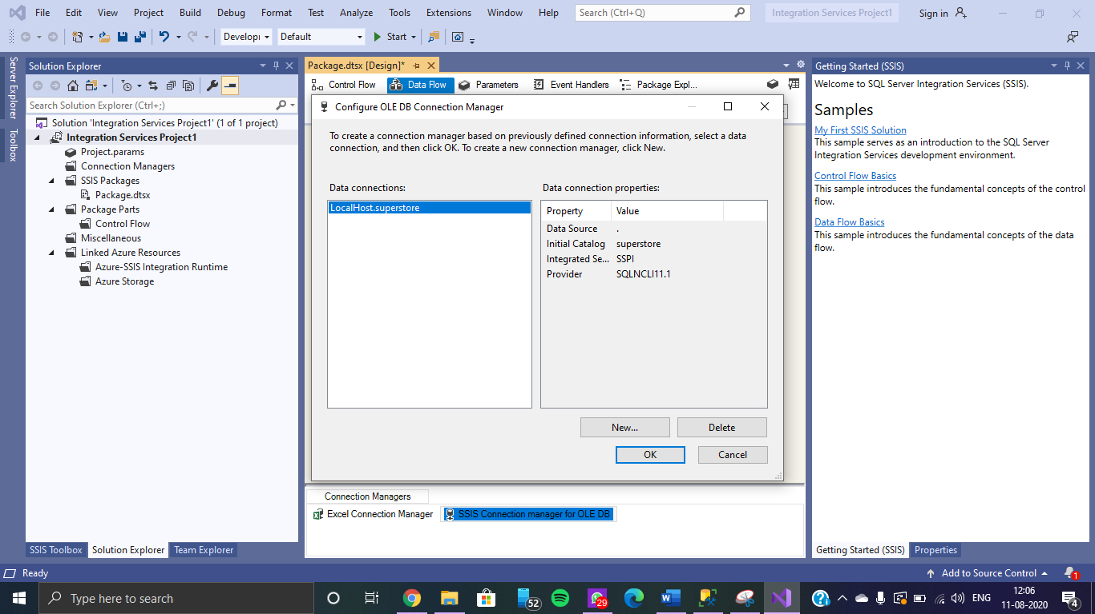

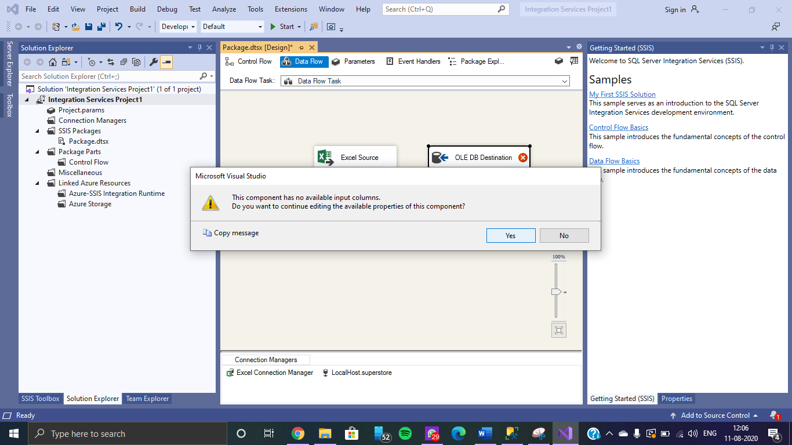

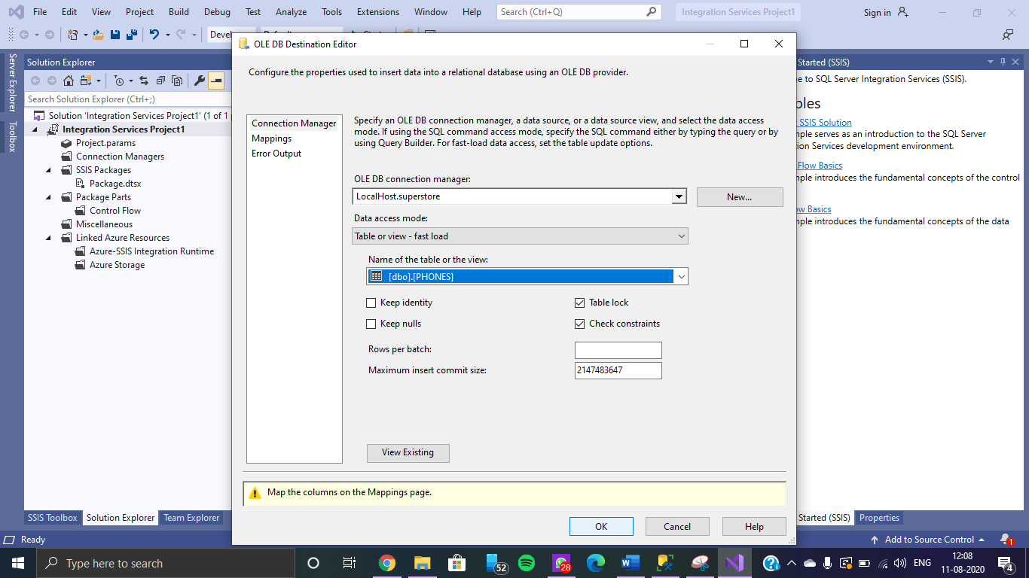

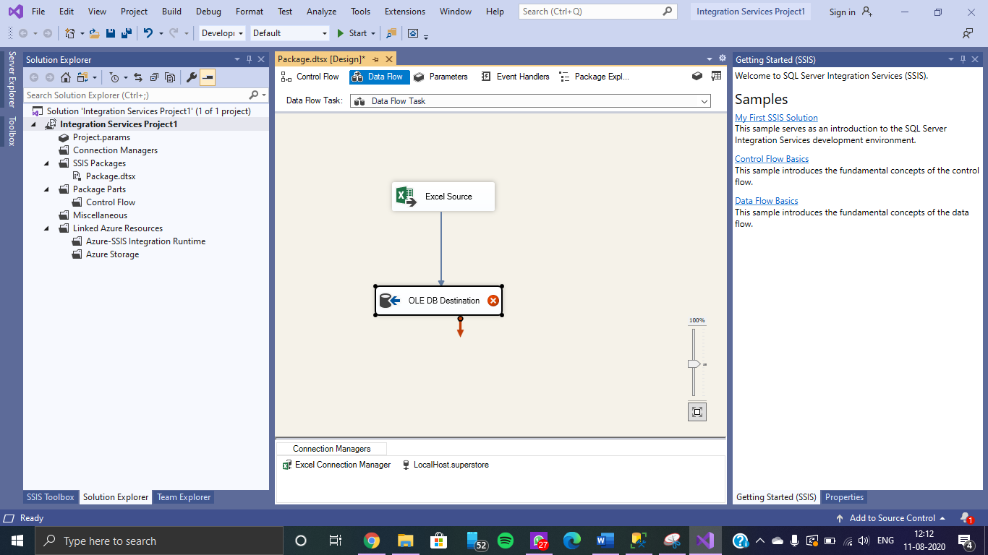

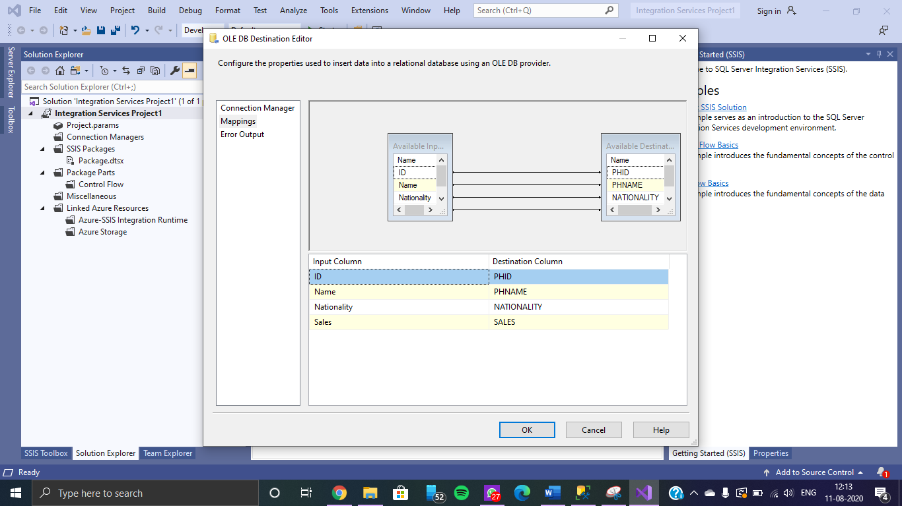

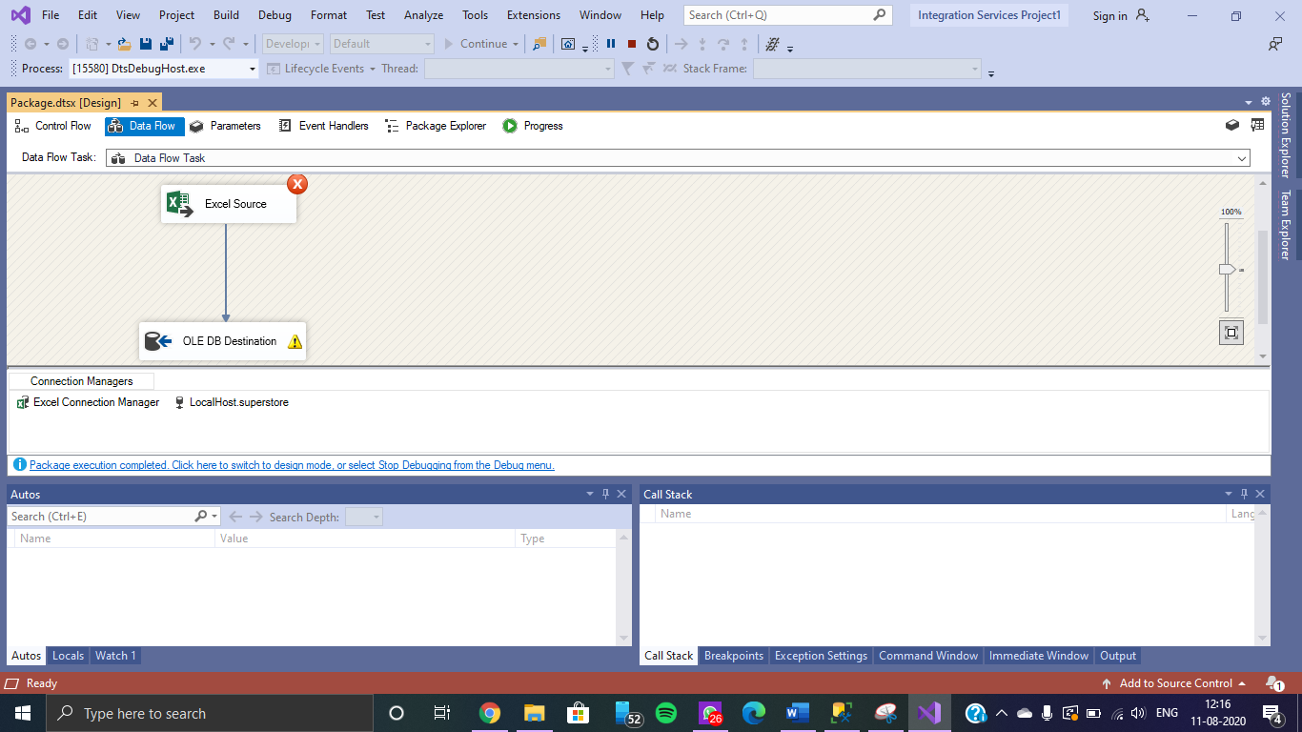

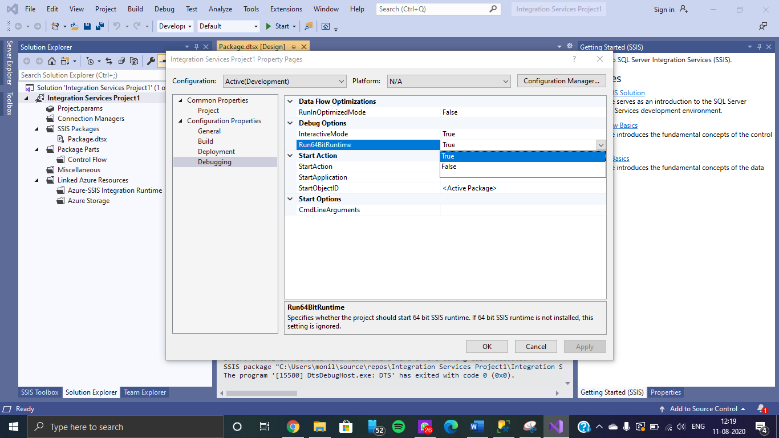

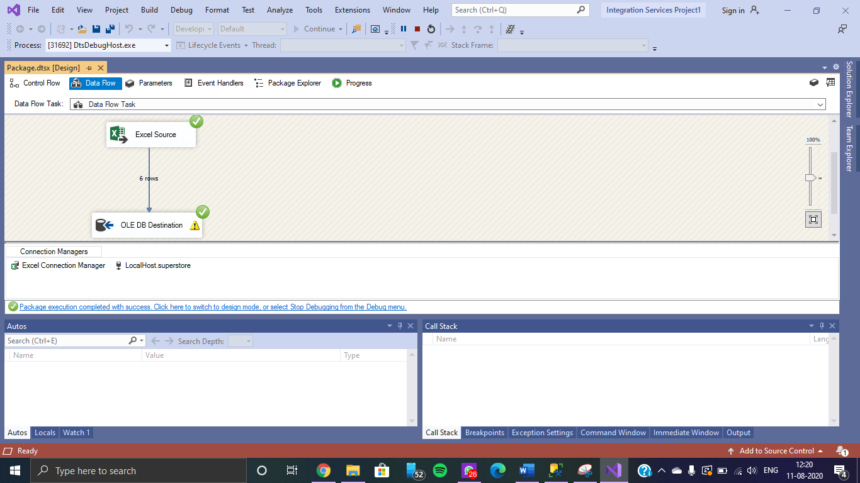

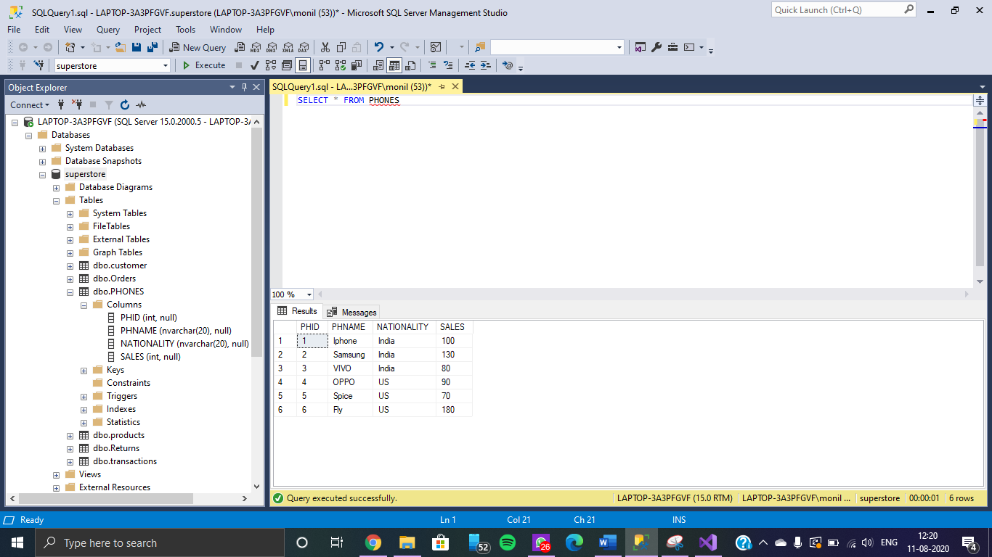

**Adding Transformation**

Sorting in Descending order on the basis of Sales

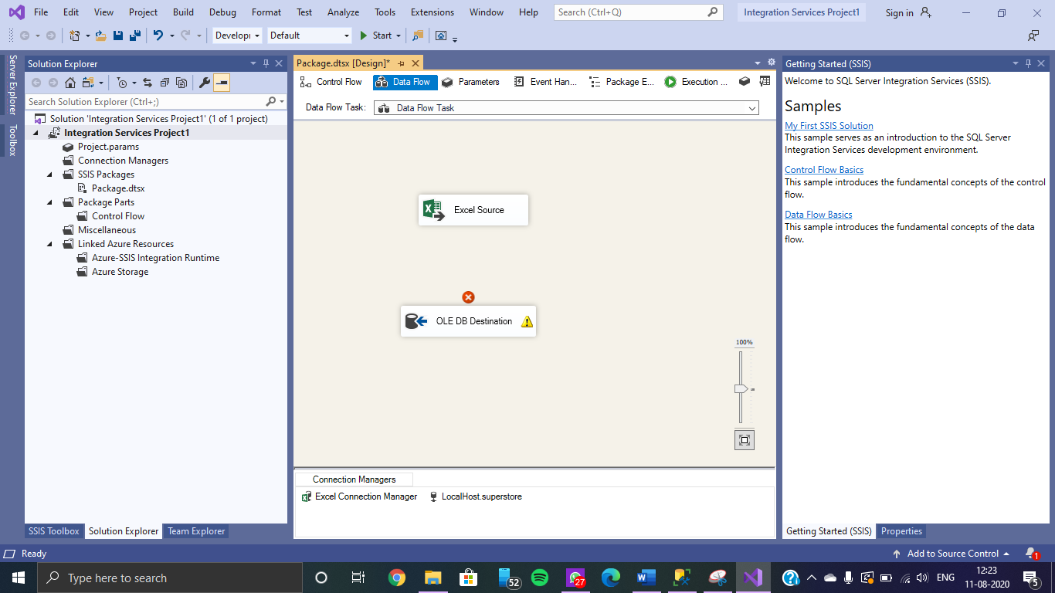

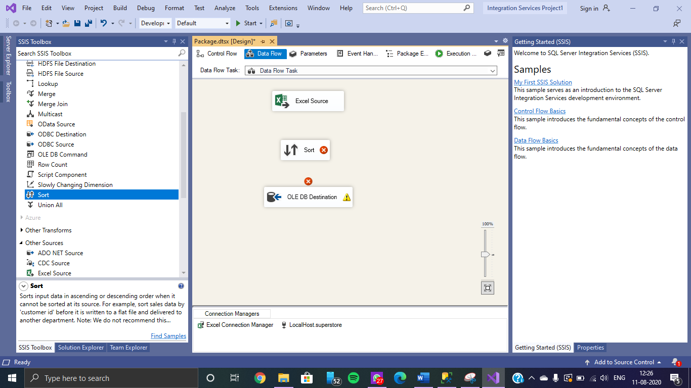

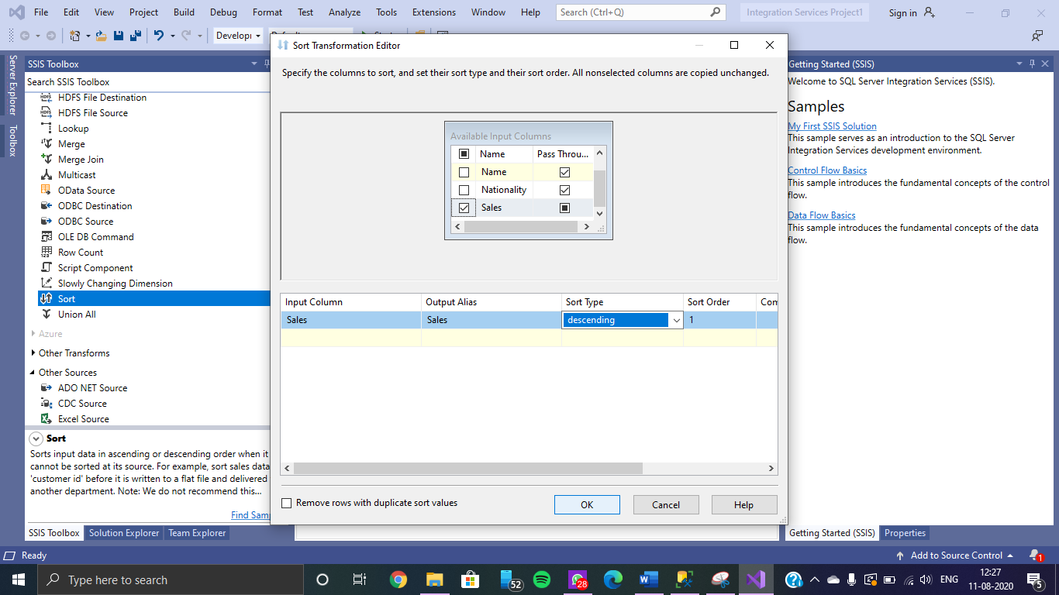

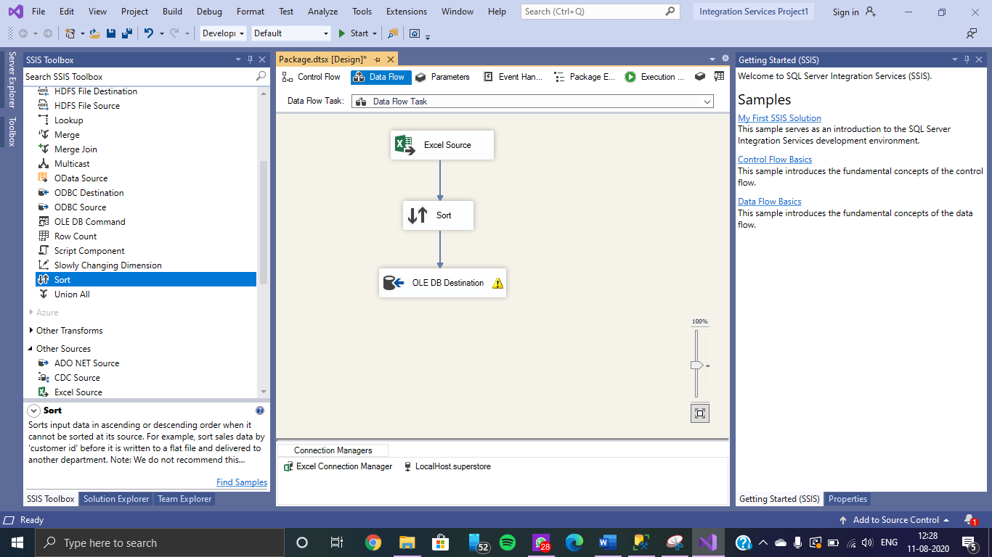

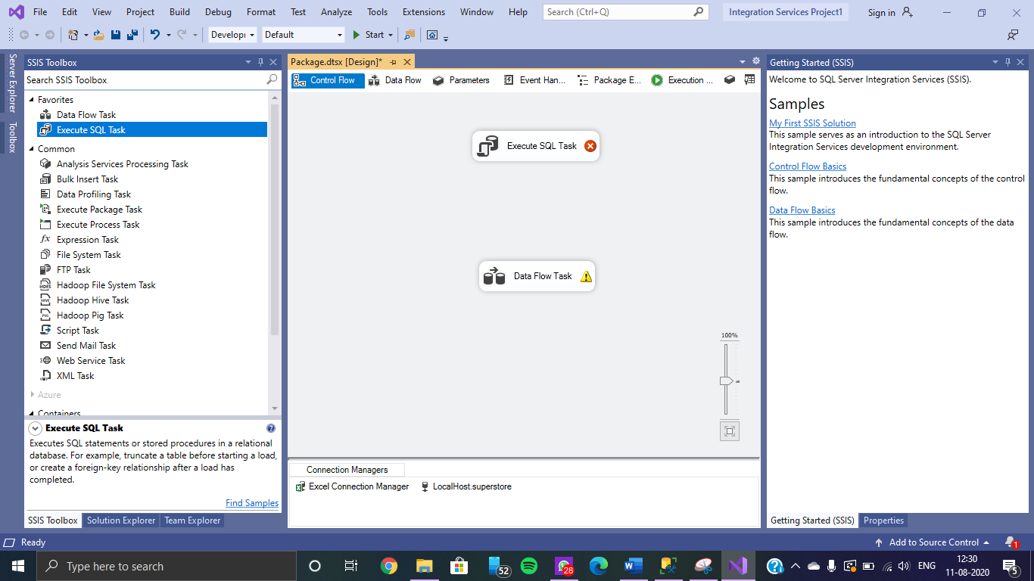

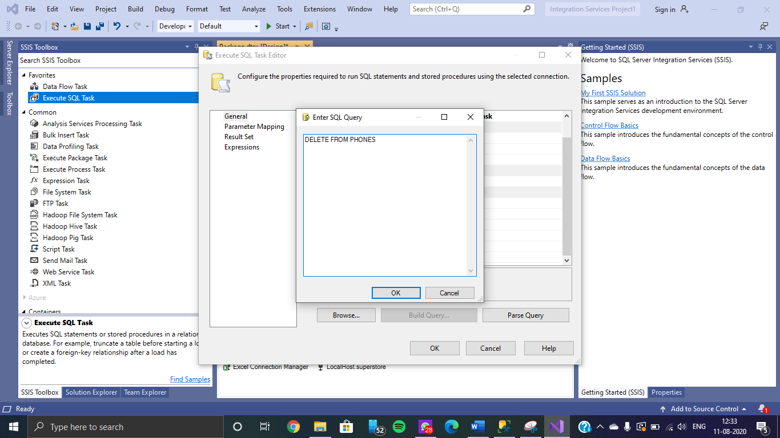

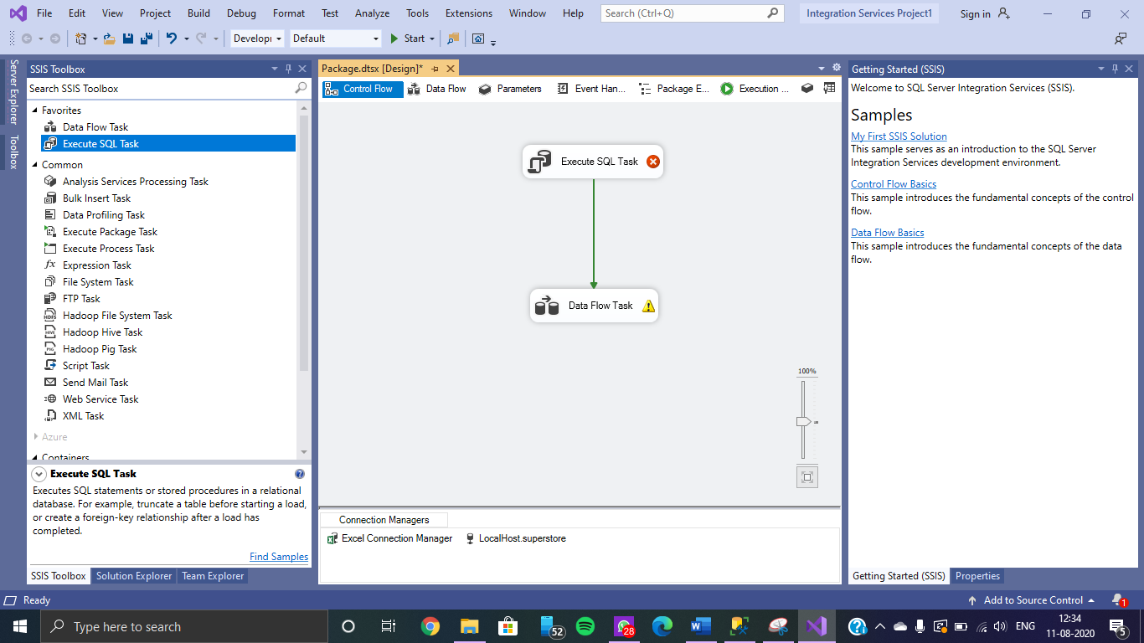

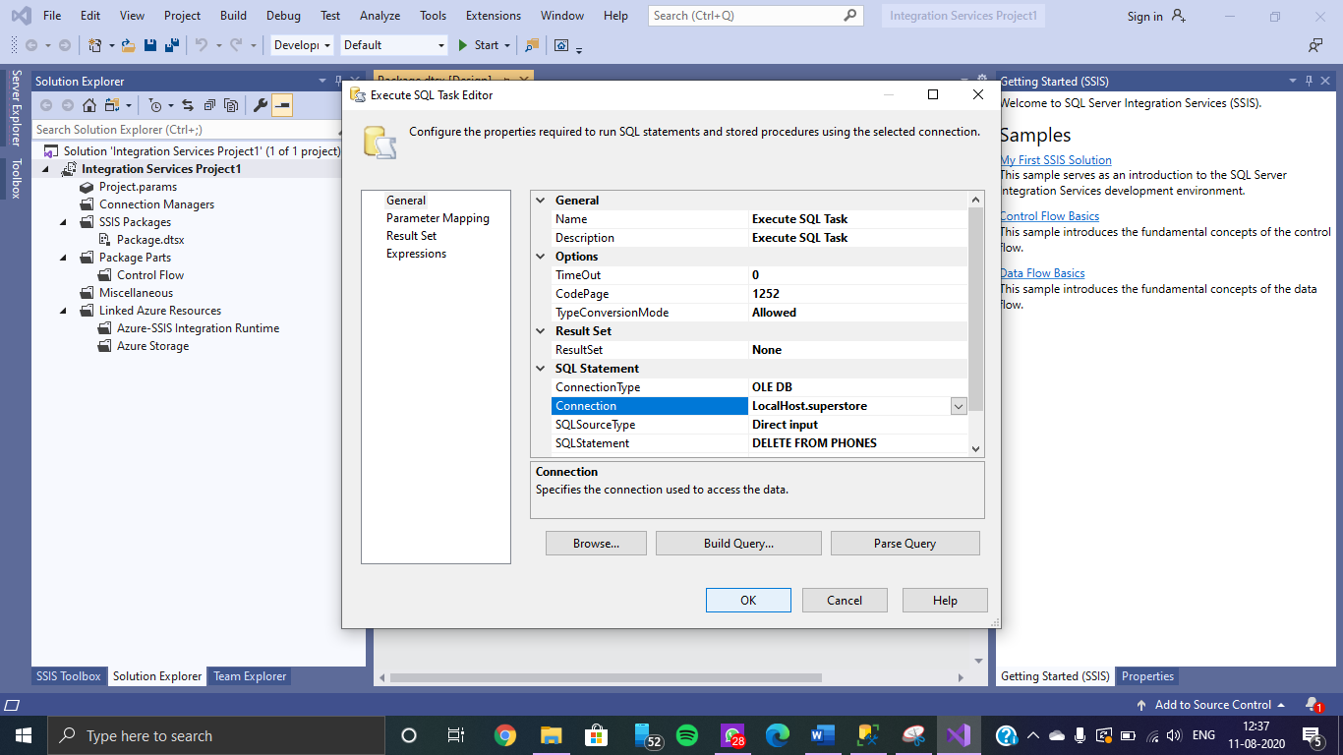

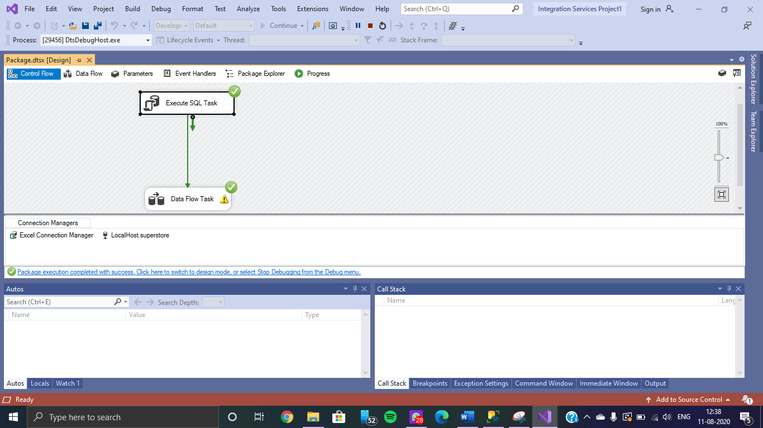

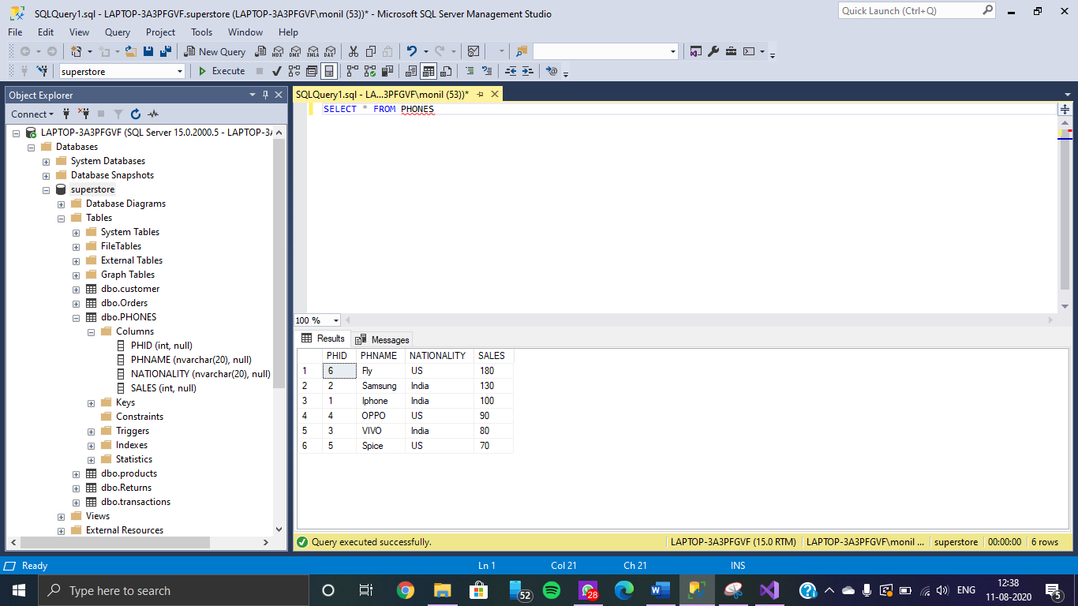

**Perform the Row Sampling Transformation**

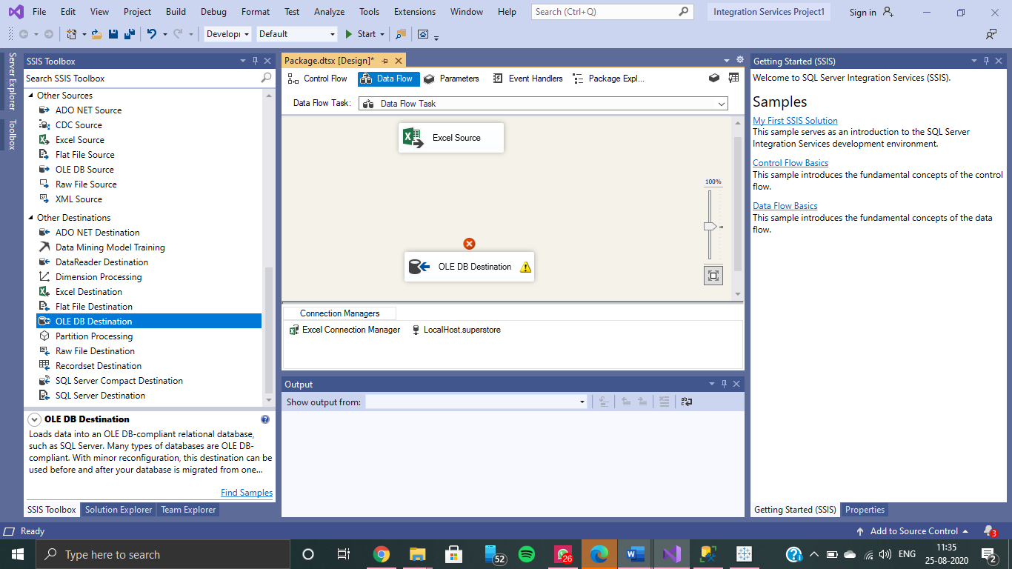

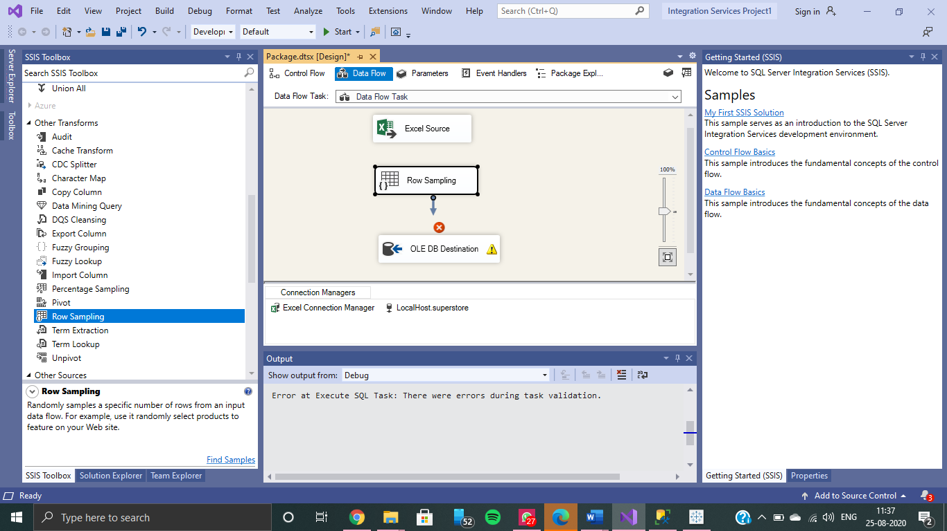

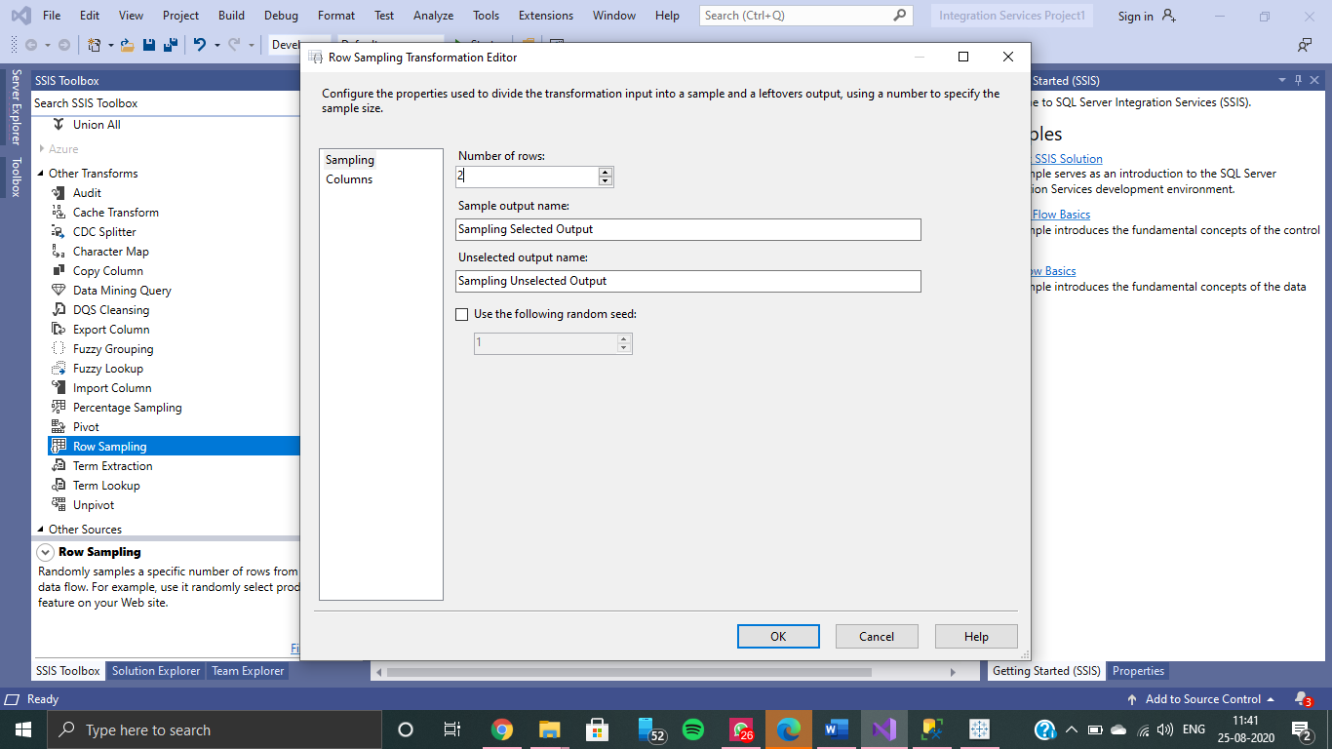

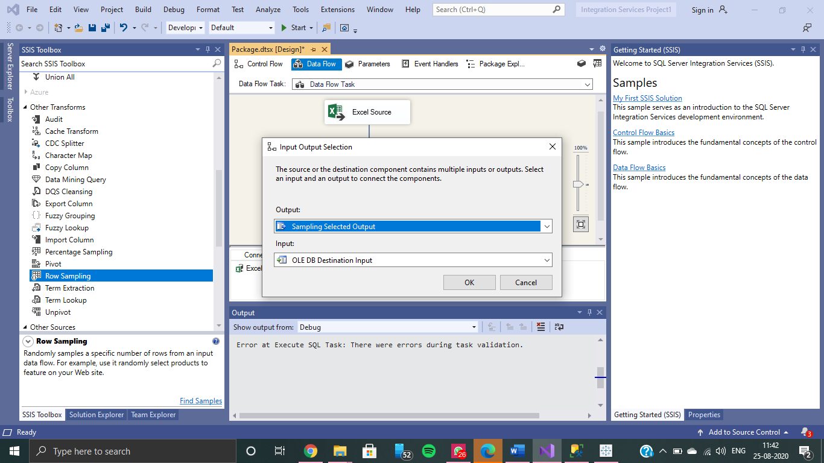

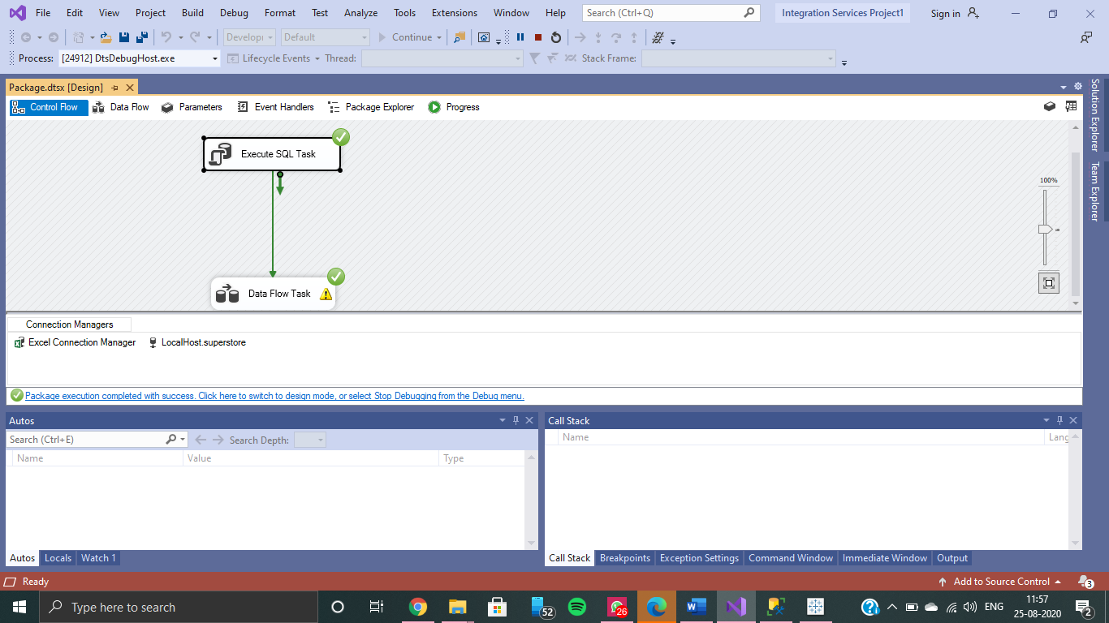

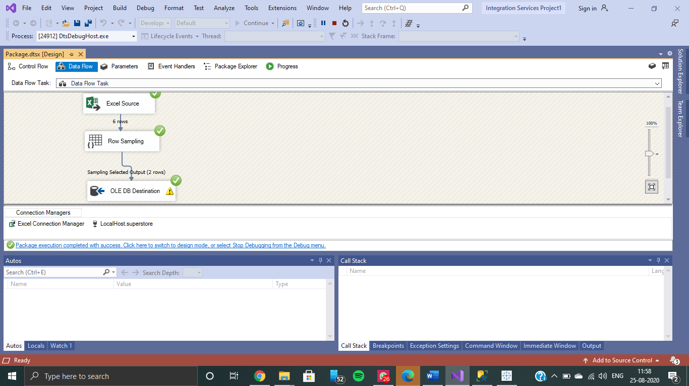

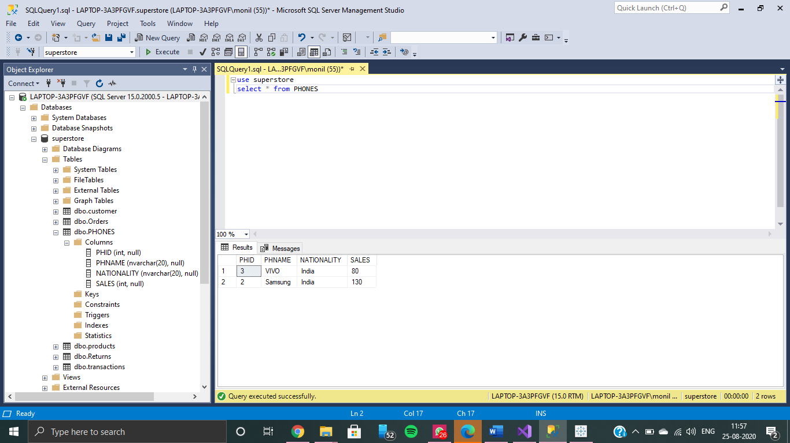

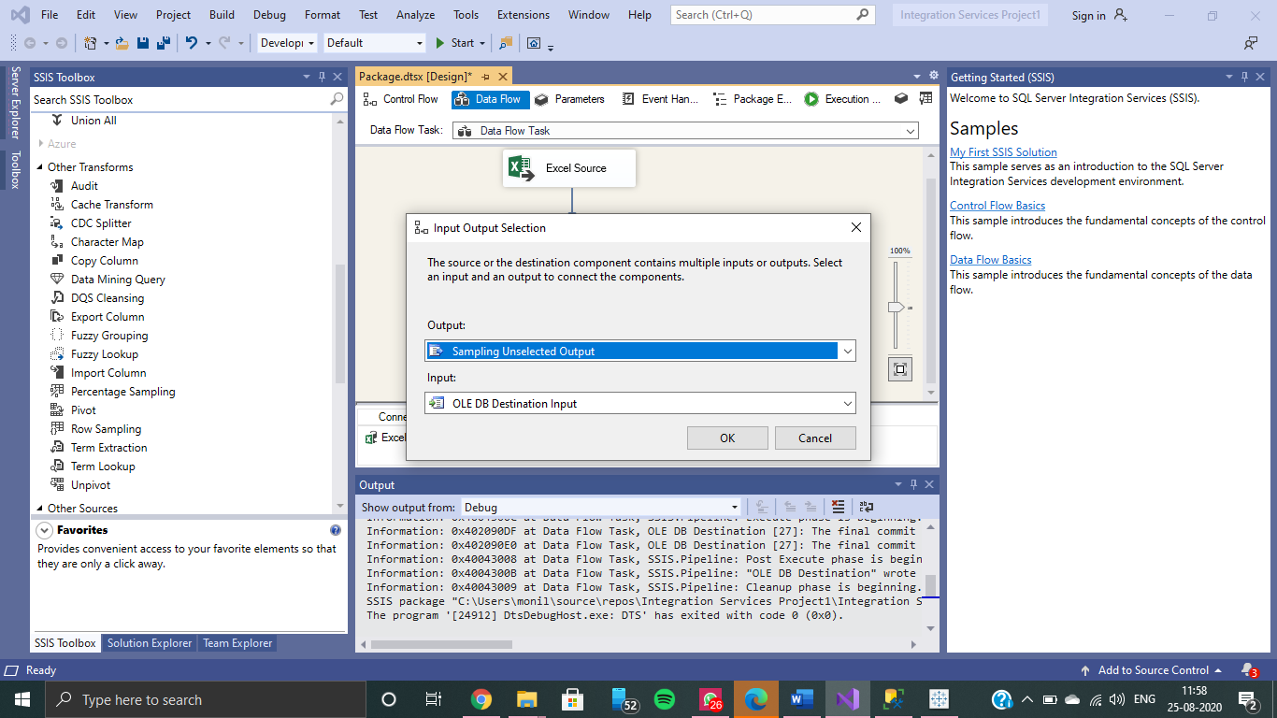



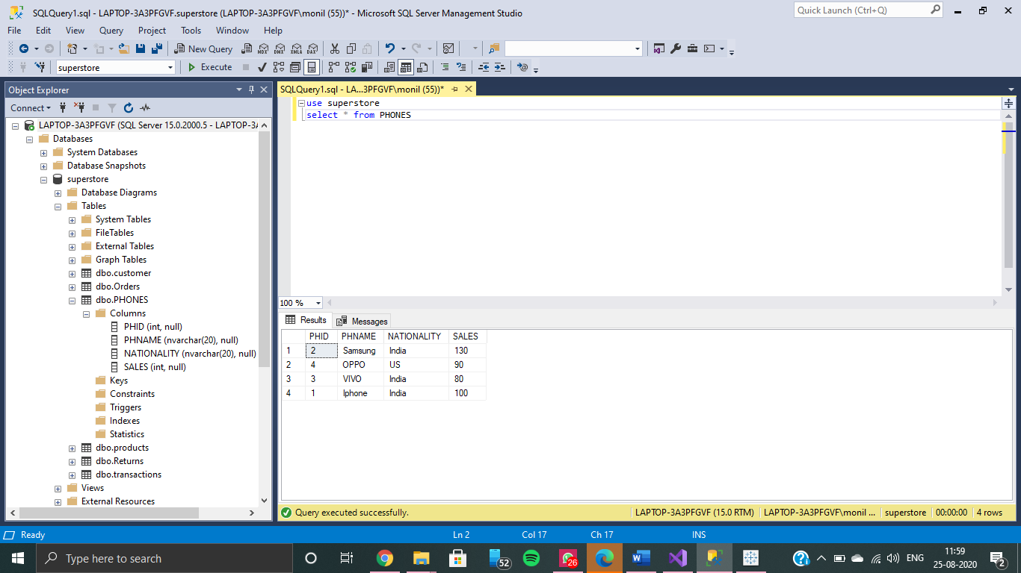

**Perform Percentage Sampling Transformation**

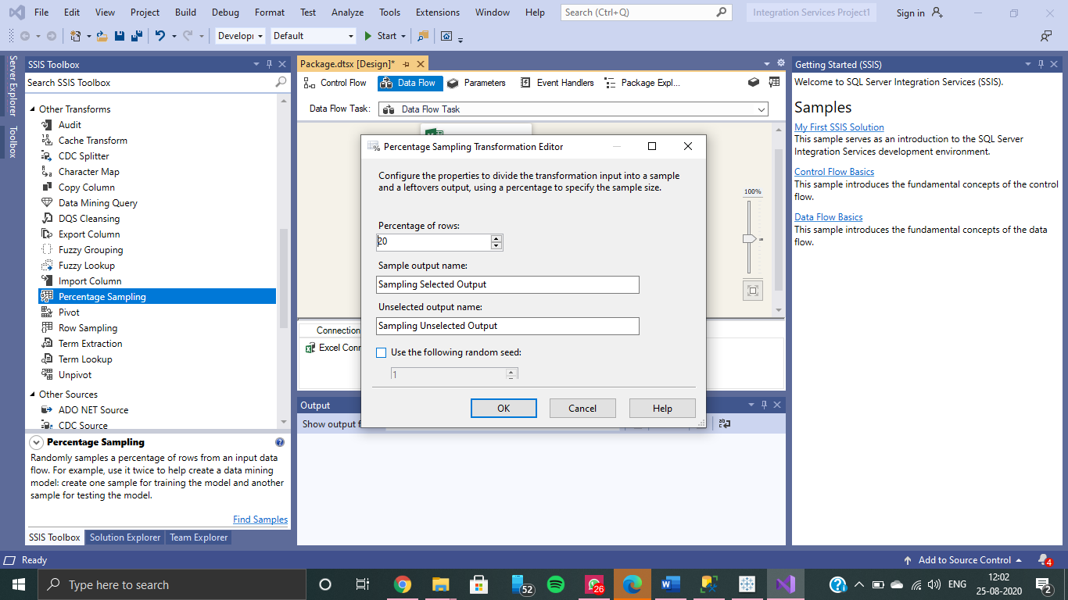

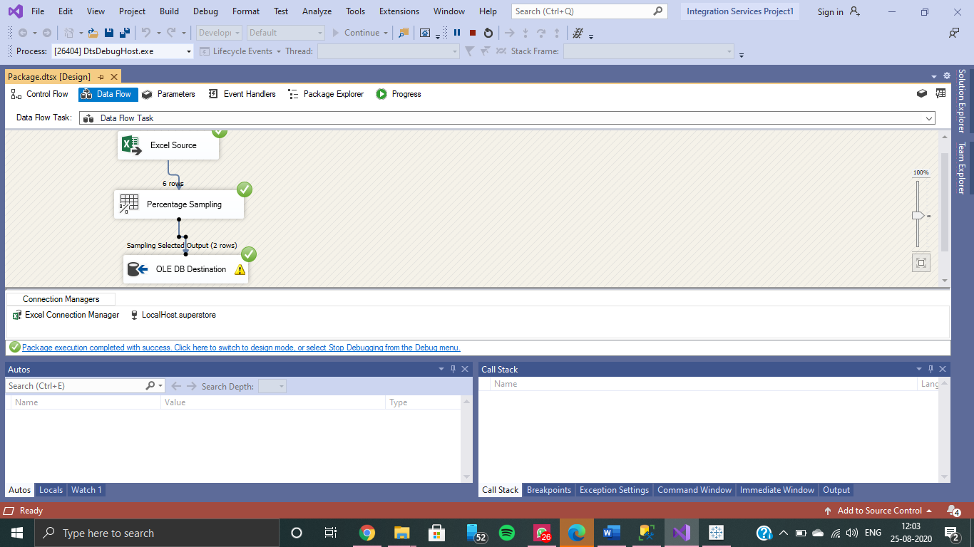

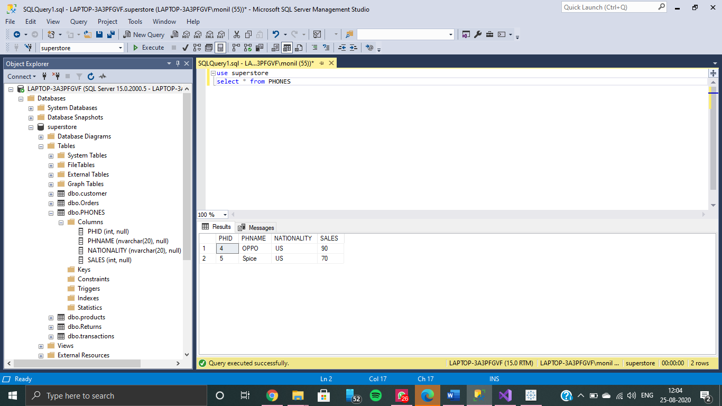

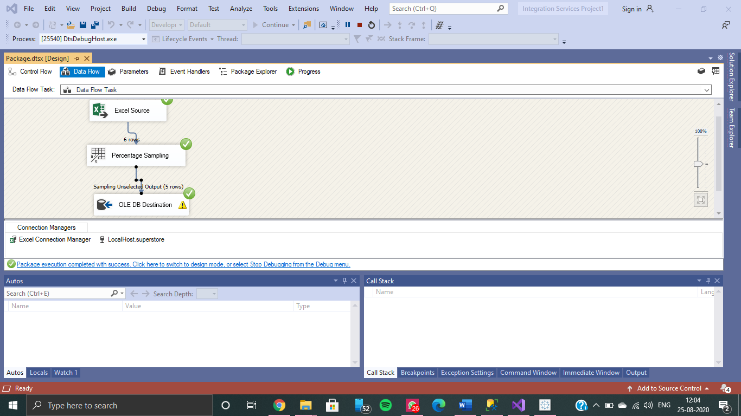

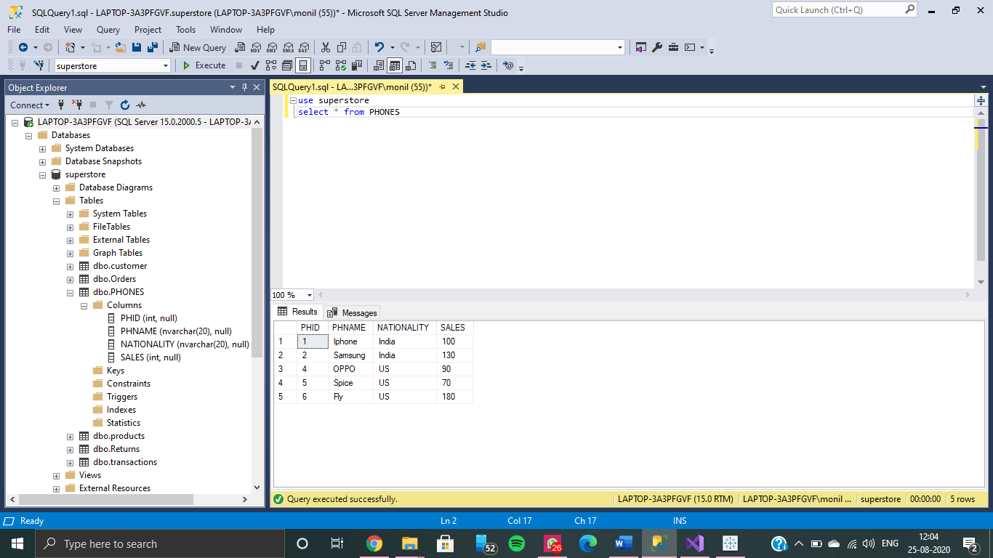

**Loading multiple sheets onto SQL Server using UNION ALL**

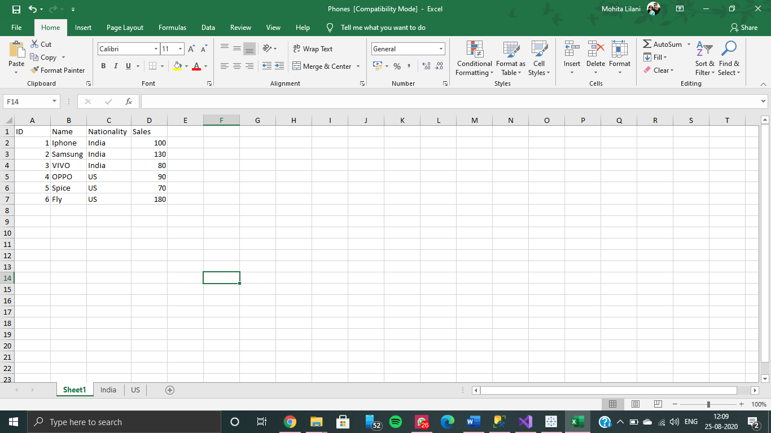

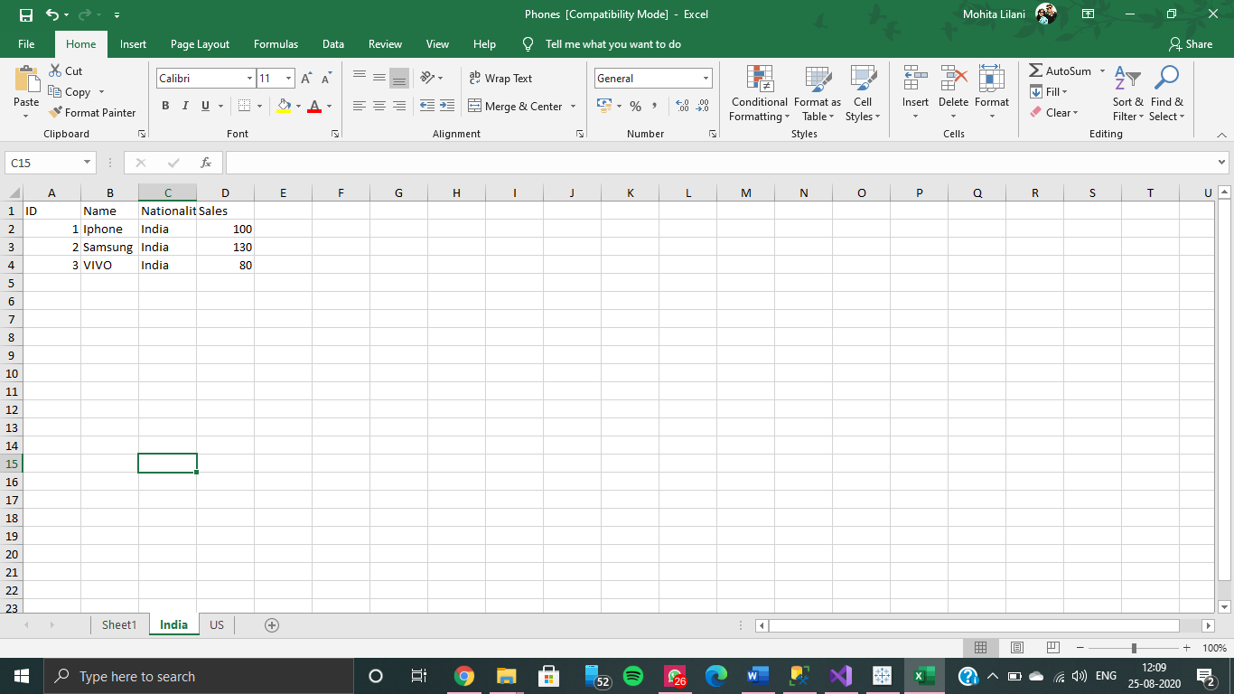

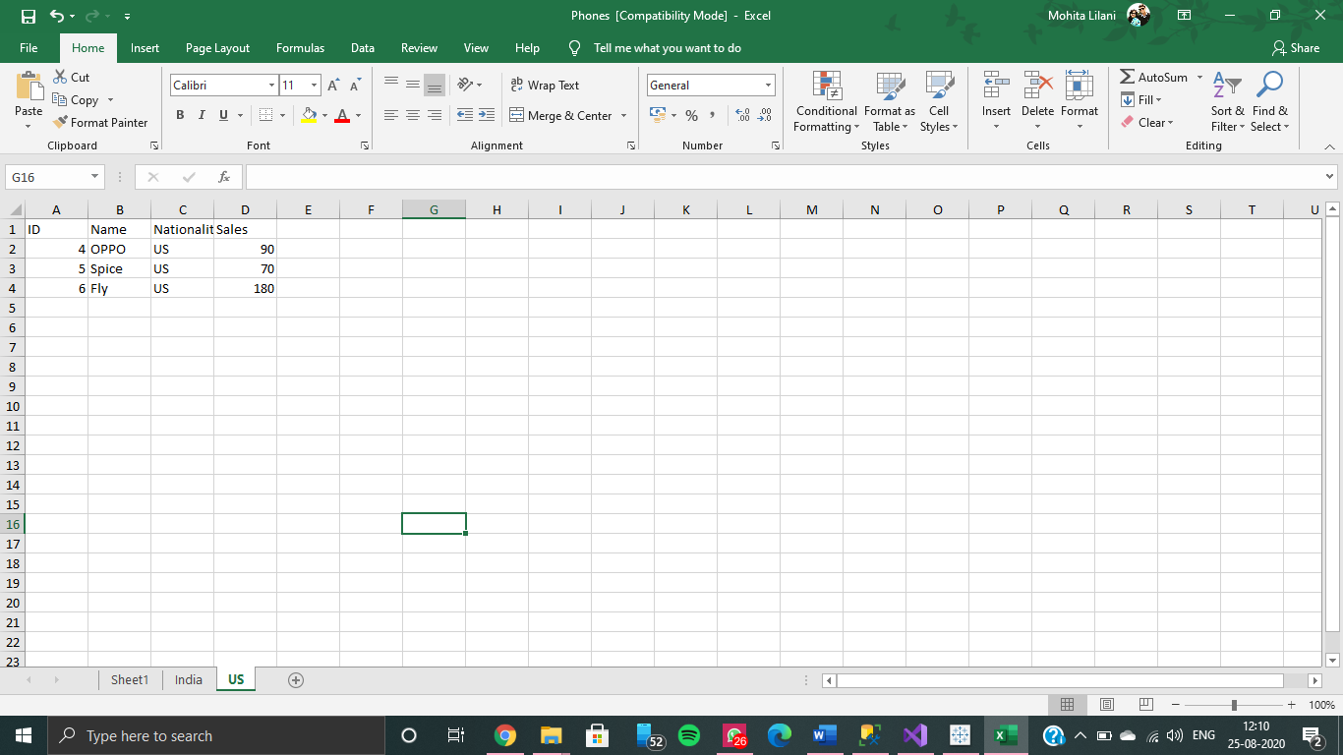

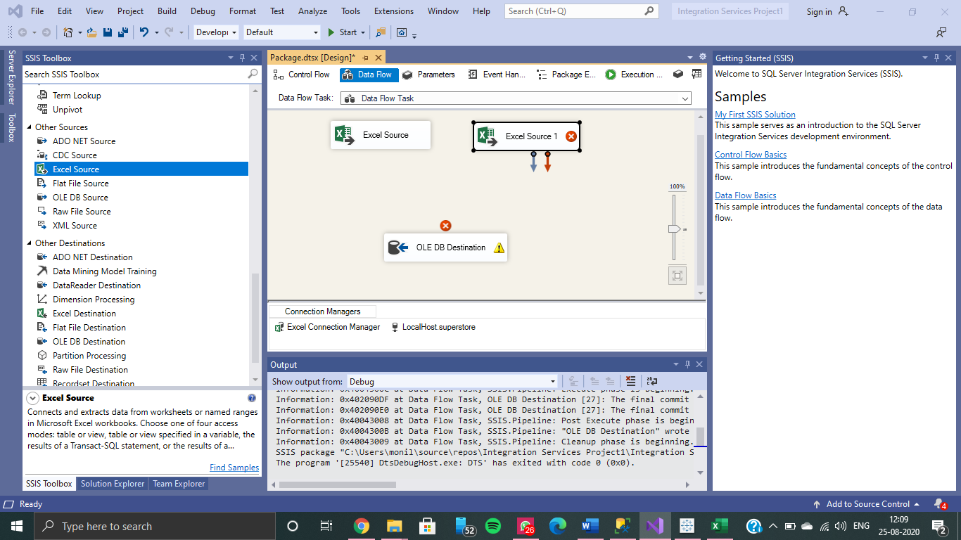

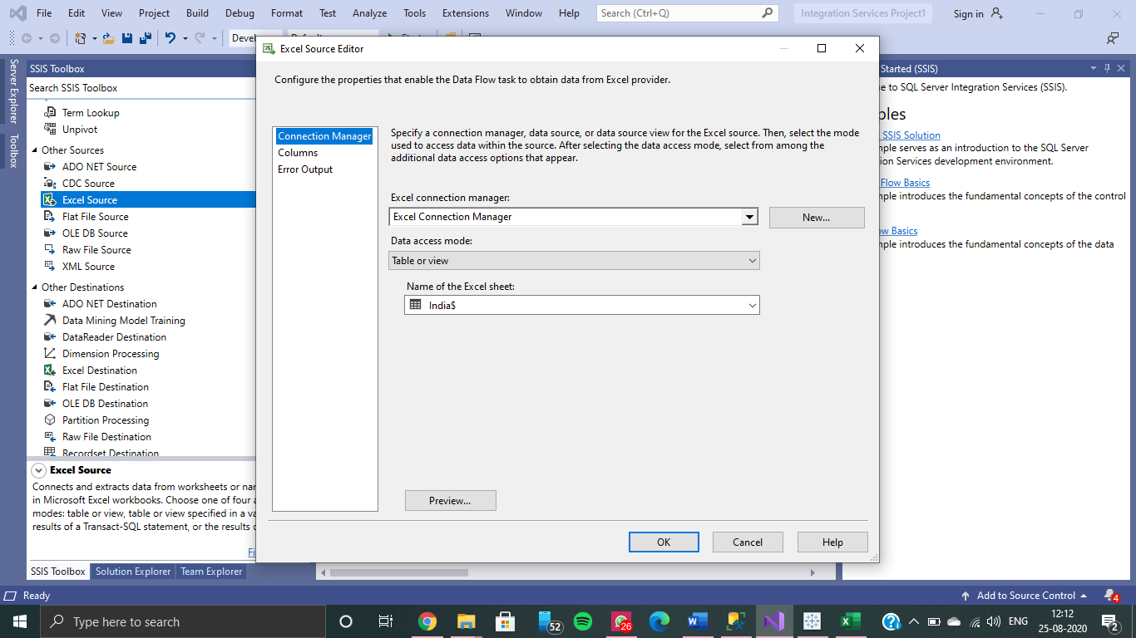

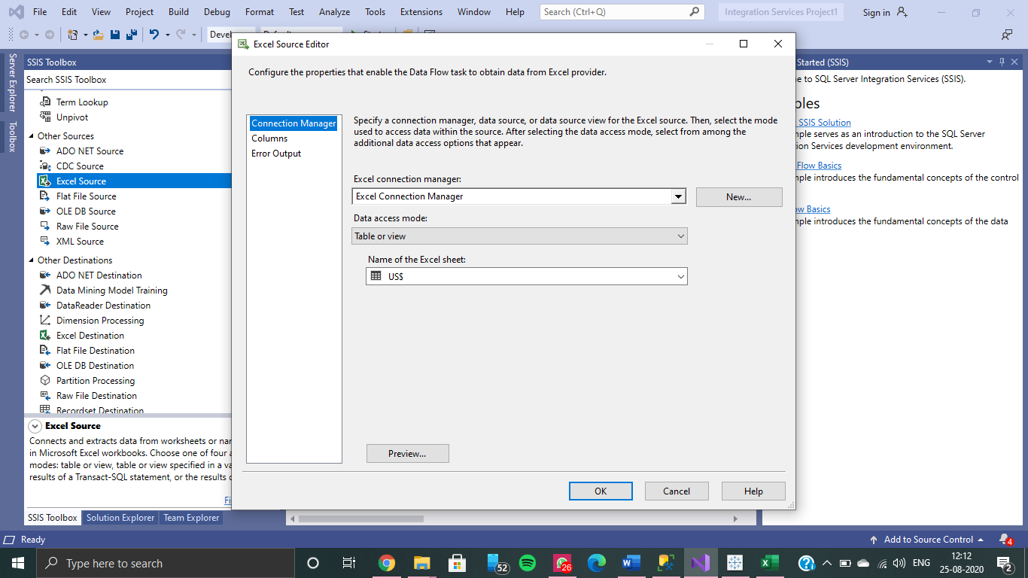

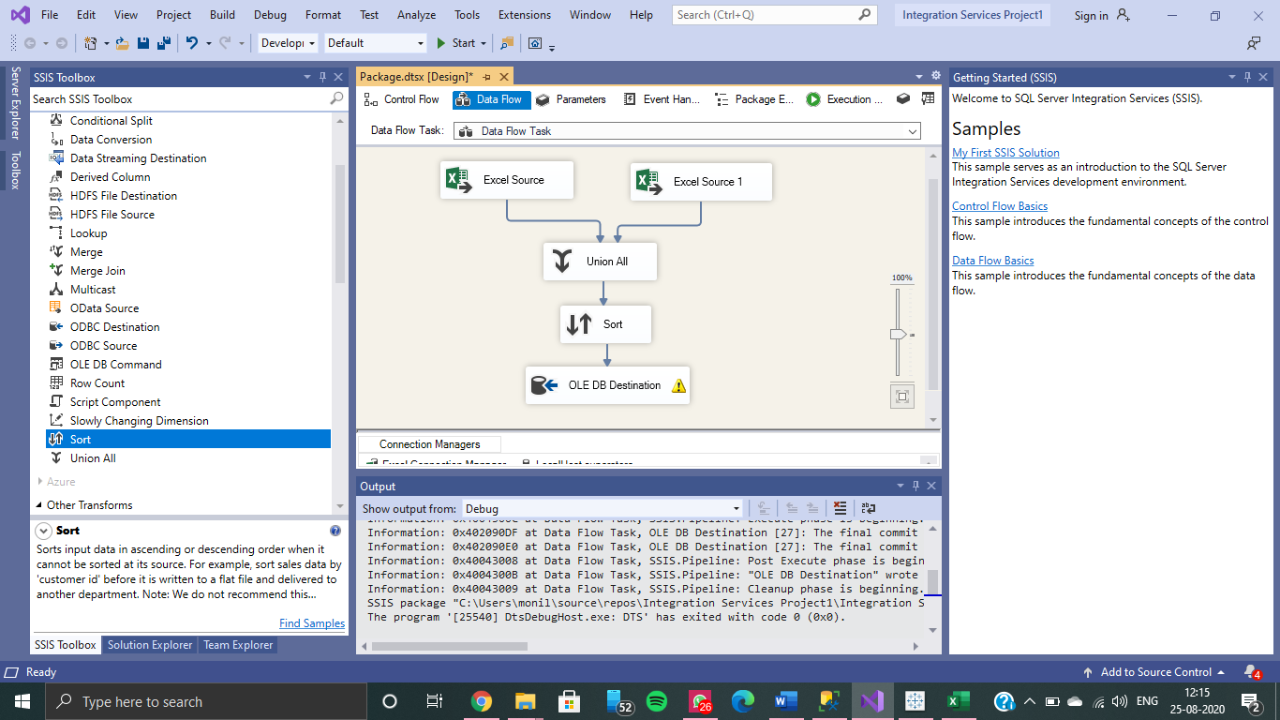

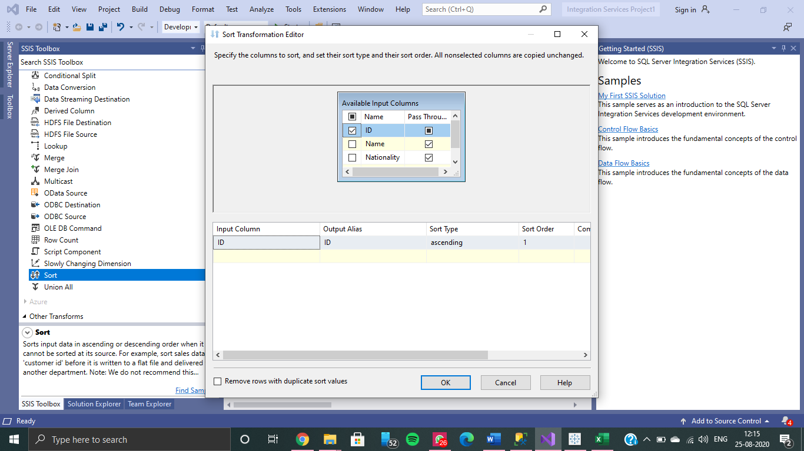

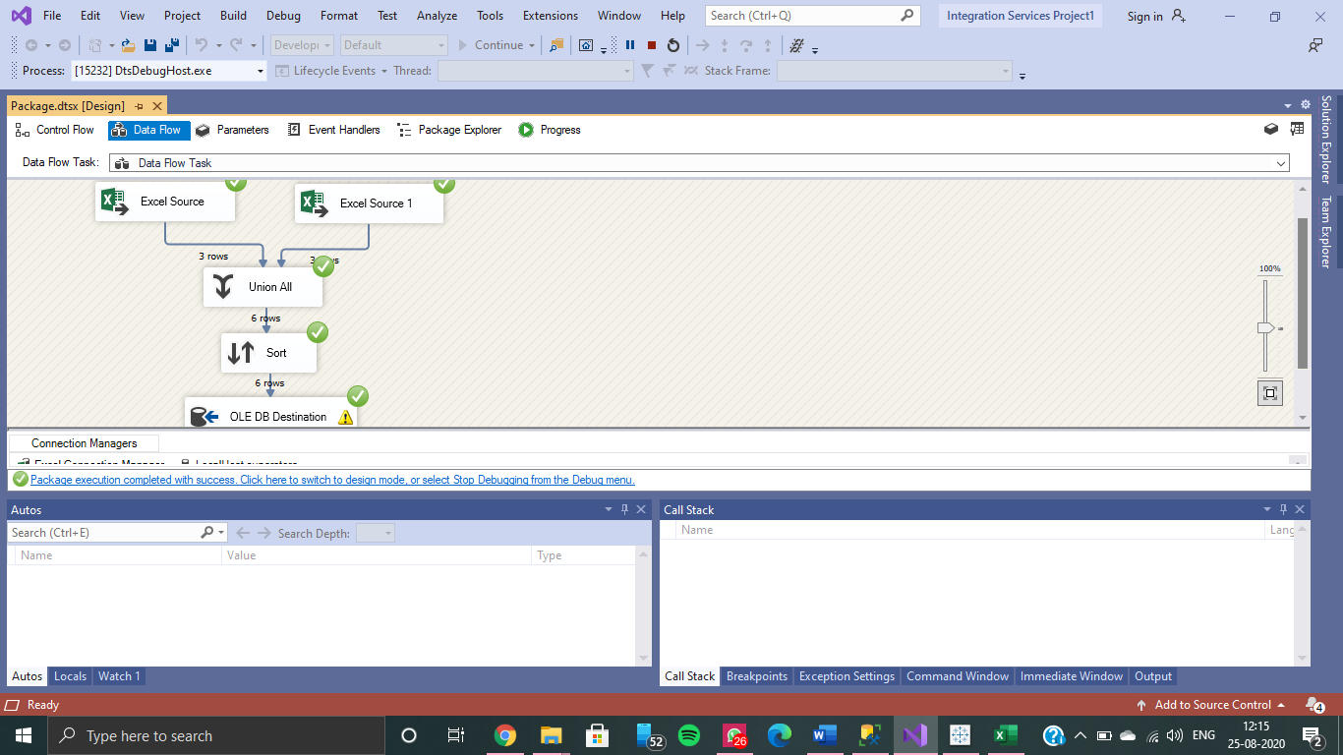

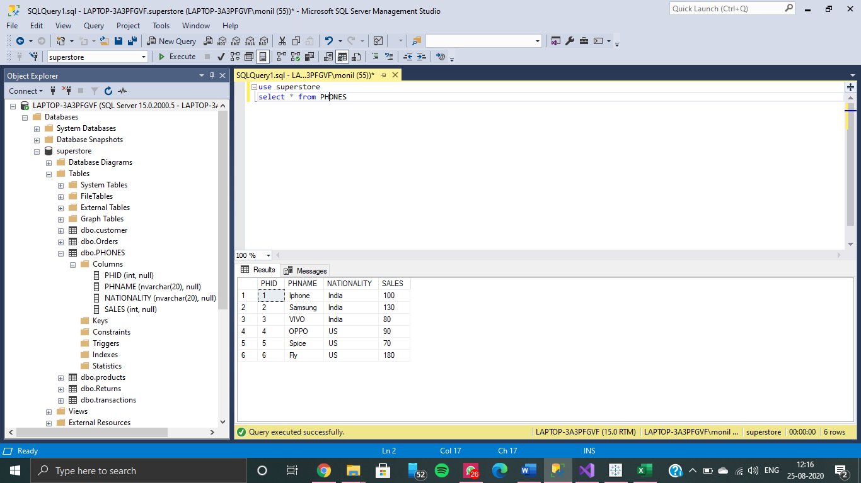

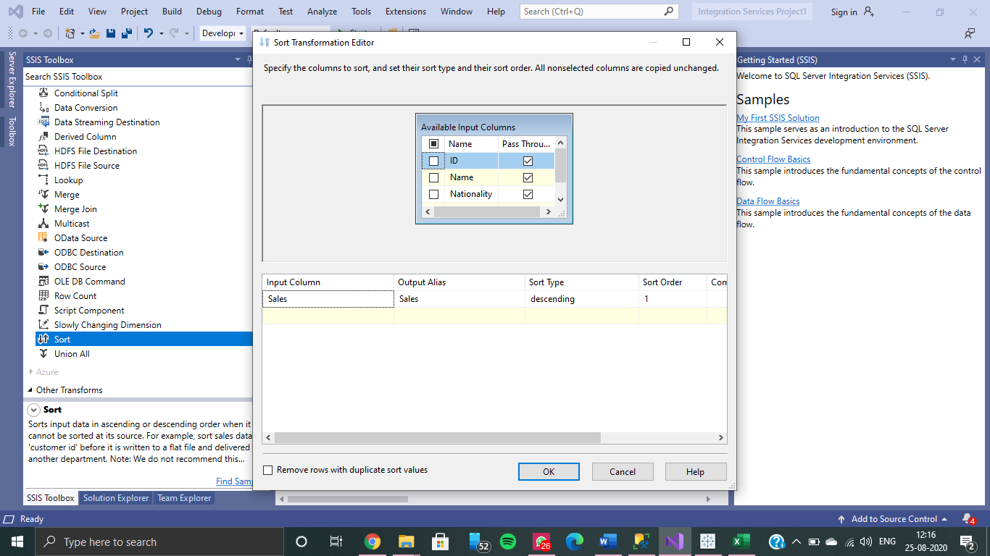

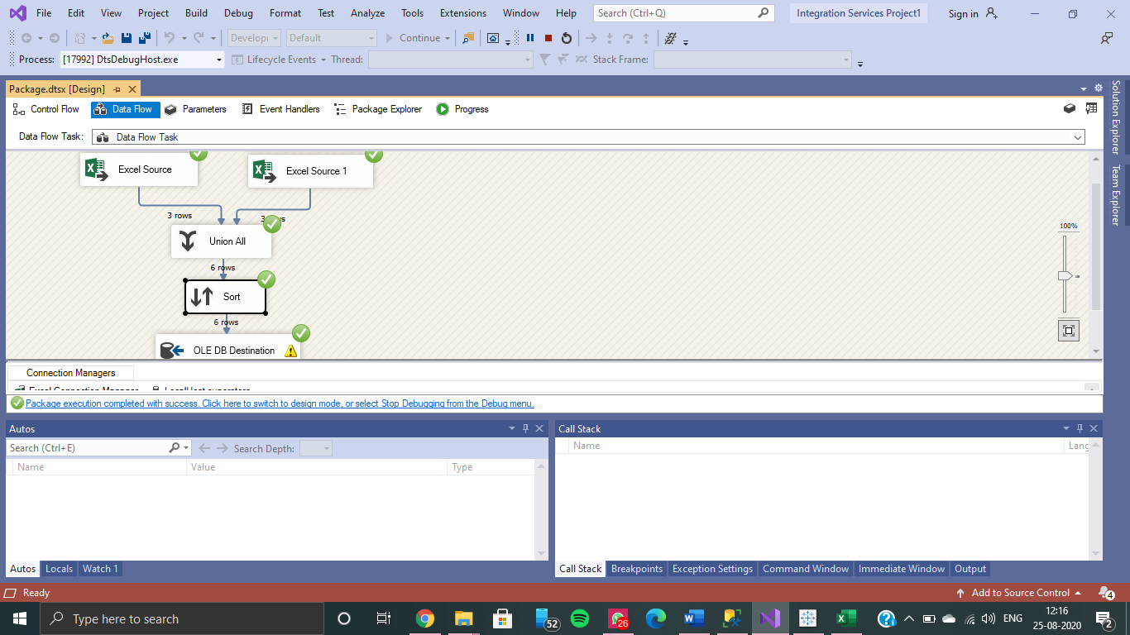

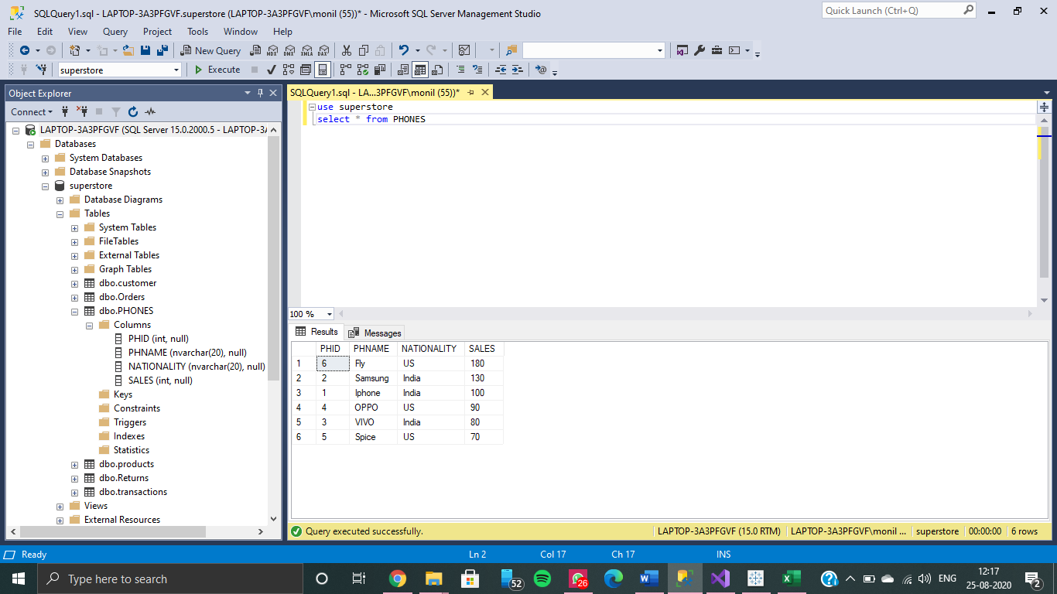

**Using the Aggregate and Union All Tool for Visualization**

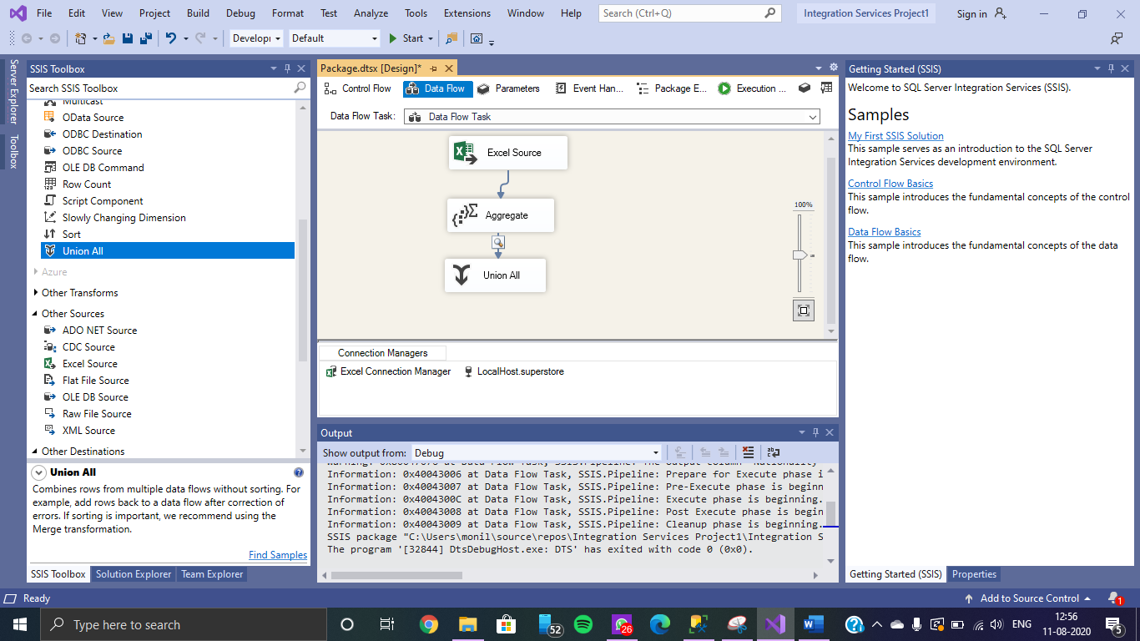

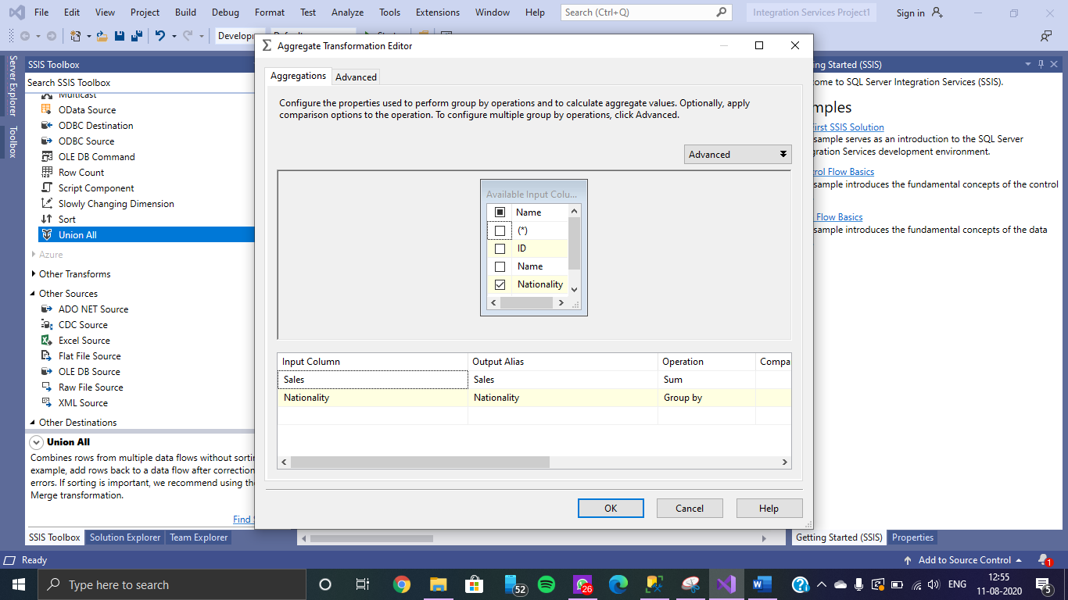

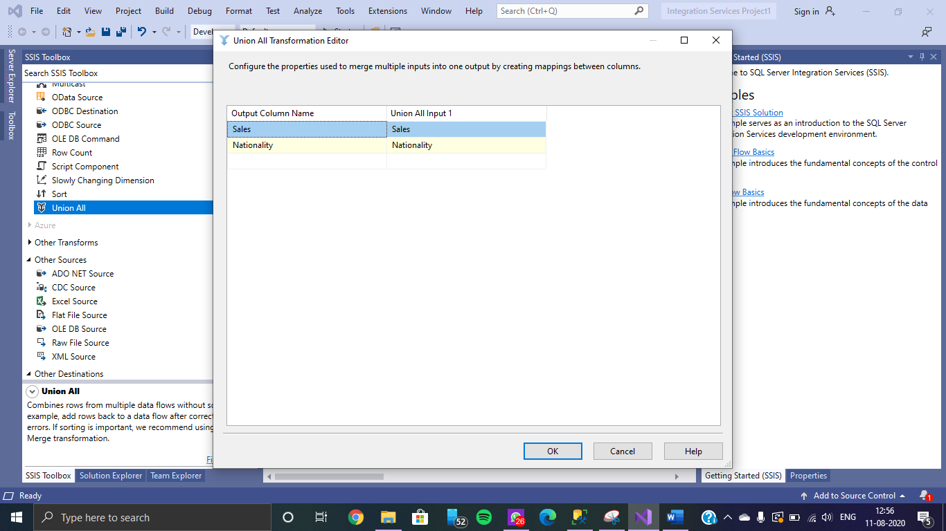

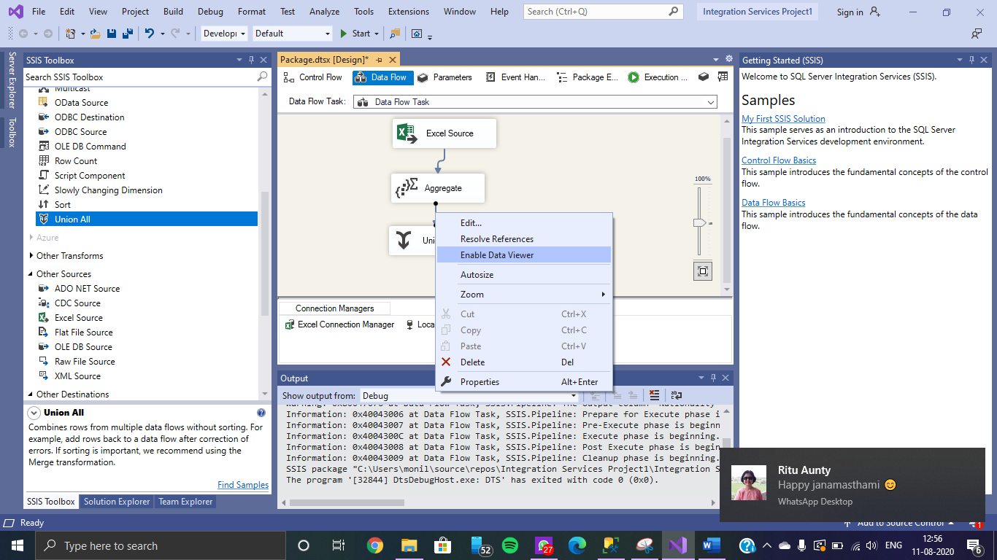

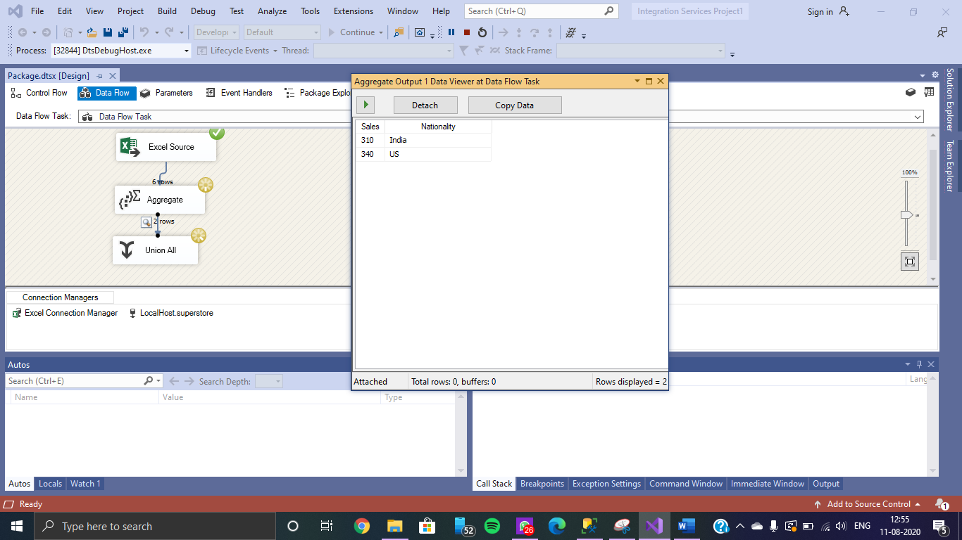

**************************

(TO BE COMPLETED BY STUDENTS)

|  |  |
| --- | --- |
| Roll No. | Name: |
| Class: | Batch: |
| Date of Practical: | Date of Submission: |
| Grade: |  |

1. Installation of SQL server 2019 & create tables under Superstore data base to understand concepts of Referential integrity.
2. Install Microsoft Visual Studio 2019 and the SSIS Package and perform ETL operation using the SSIS Package on the Microsoft Visual Studio 2019.

**\*\*\*\*\*\*\*\*\*\*\*\*\*\*\*\*\*\*\*\*\*\*\*\*\*\*\*\*\*\***